

**RAMNIRANJAN JHUNJHUNWALA COLLEGE GHATKOPAR (W), MUMBAI - 400 086**

**DEPARTMENT OF INFORMATION TECHNOLOGY**

**2023 - 2024**

**t.Y. B. Sc.( I.T.) SEM v**

**Paper rjsuit504– linux system administration**

**Name Rajbhar Sudesh Dinesh**

**Roll No. 6417**

**Hindi Vidya Prachar Samiti’s**

**RAMNIRANJAN JHUNJHUNWALA COLLEGE**

**Ghatkopar (W), Mumbai-400 086**

***Certificate***



**This is to certify that Mr.Rajbhar Sudesh Dinesh, Roll No. 6417 of T.B.Sc.(I.T.) class has completed the required number of experiments in the subject of Linux System Administration in the Department of Information Technology during the academic year 2023- 2024 .**

**Professor In-Charge Co-ordinator of IT Department**

**Prof. Bharati Bhole**

**Prof. Archana Bhide**

**College Seal & Date Examiner**

INDEX

| **PRAC NO:** | **PRACTICAL** | **DATE** | **REMARK** |
| --- | --- | --- | --- |
| 0. | Installation of RHEL 6.X | 22/06/2023 |  |
| 1. | Graphical User Interface and Command Line Interface and Processes | 06/07/2023 |  |
|  | * Exploring the Graphical Desktop |  |  |
|  | * The Command Line Interface |  |  |
|  | * Managing Processes |  |  |
| 2. | Storage Devices and Links, Repository | 13/07/2023 |  |
|  | * Working with Storage Devices and Links |  |  |
|  | * Creating a Repository |  |  |
| 3. | Networking | 10/08/2023 |  |
|  | * Connecting to the Network |  |  |
| 4. | Working with Users, Groups, and Permissions | 10/08/2023 |  |
| 5. | Firewall | 16/09/2023 |  |
|  | * Securing Server with iptables |  |  |
| 6. | Setting Up File Server. | 03/10/2023 |  |
| 7. | Configuring DNS Server. | 18/09/2023 |  |
| 8.. | Setting up Mail Server | 16/09/2023 |  |
|  | * Configuring mail using mutt |  |  |
| 9. | Working on Shell Scripts | 09/09/2023 |  |
| 10. | Configuring booting with GRUB | 03/10/2023 |  |

| **PRACTICAL NO 0: Installation of RHEL 6.X** |
| --- |

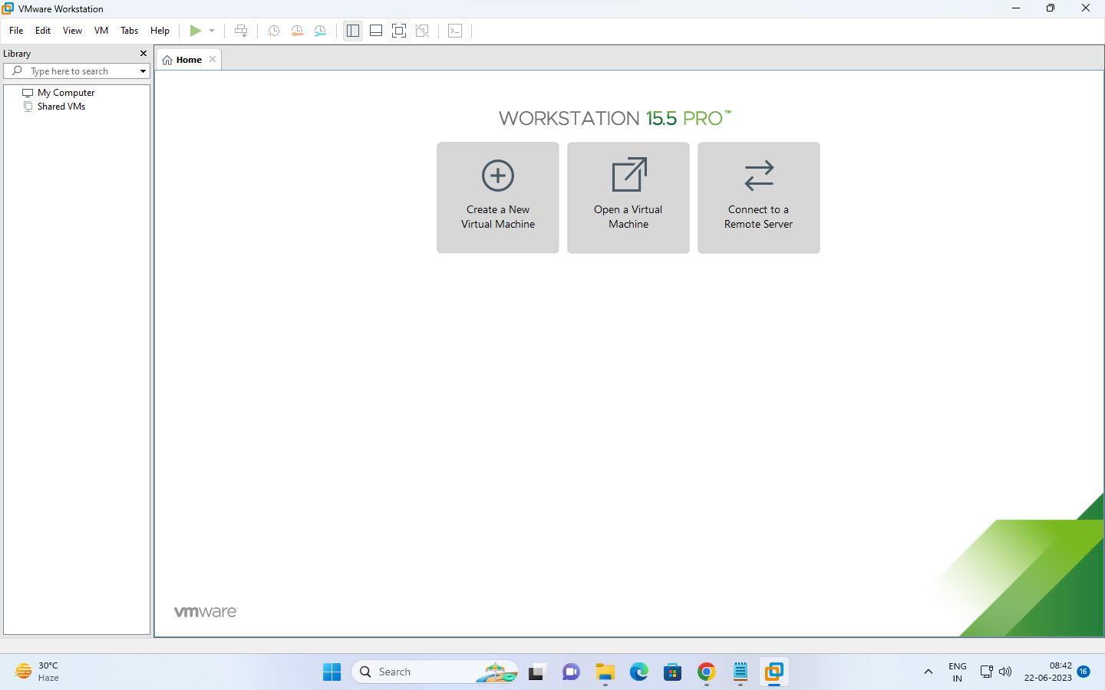

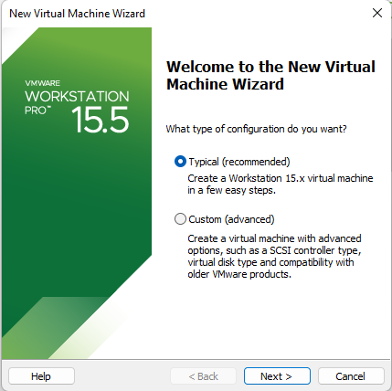

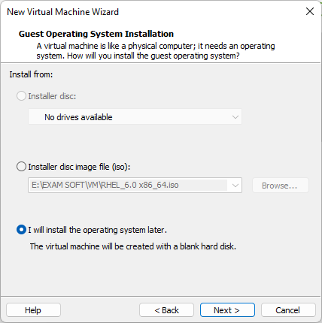

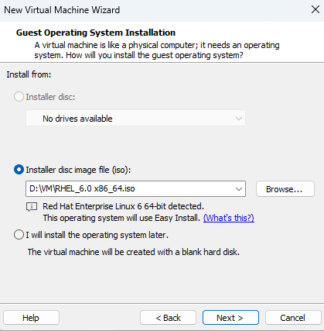

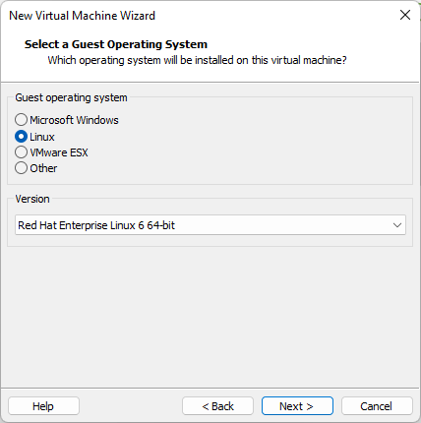

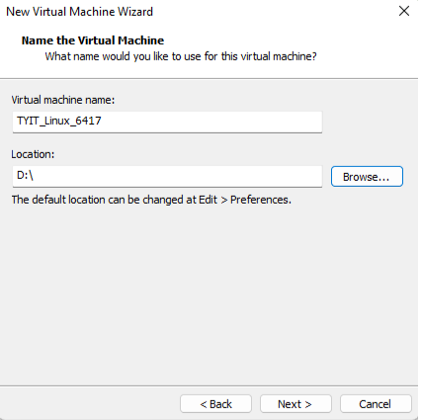

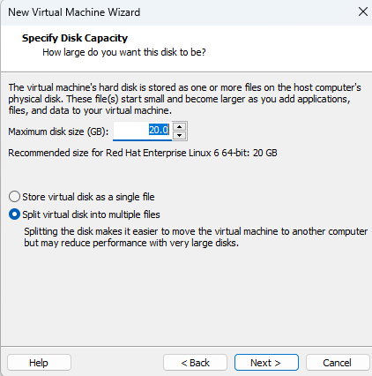

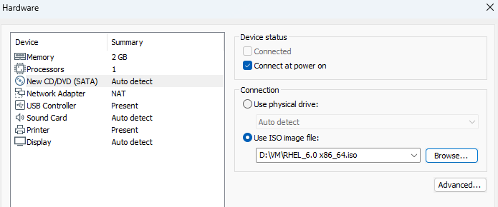

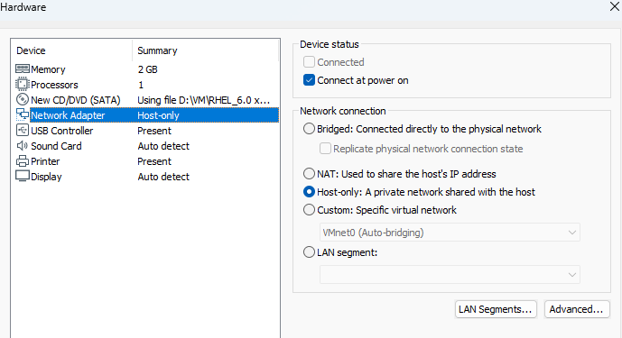

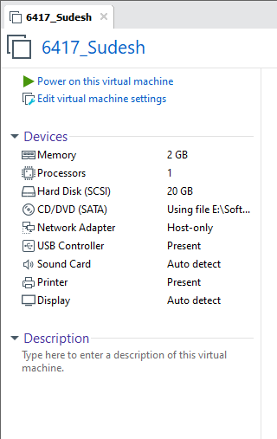

**Configuration:**

| **Written Steps For Installation :**   1. Create a New Virtual Machine 2. Choose Iso File Then Select Last 3. Then Next 4. Then Select Linux Then Red Hat Linux 5. Next 6. VIrtual Machine Name - TYIT_Linux_6403 7. Browse The location to Your Folder 8. Disc size = 20gb 9. Split into multiple files 10. Next 11. Then customize hardware 12. Next 13. Then 3rd option New CD DVD Sata in that browse the iso file and click 1s option connect at power on 14. tHen Network Adapter 15. Connect at power on 16. Host only : Ap private—---- option 17. Close 18. Finish 19. Then Power ON The VM Machine 20. Alt then enter for skip 21. The click Then next then U.S.english 22. Then next 23. Basic storage device 24. Next 25. Reinitialize all 26. Next 27. Next 28. Asia/Kolkata 29. Password - tyituser 30. Username - root 31. Next 32. Use ANyway 33. Create Custom Layout - —----last option 34. Click Create → Standard partition → Create total 3 times 35. Mount Point - / 36. File type - ext4 37. Size - 10000 38. 2nd last force to be primary partition 39. Fixed size 41. Create again 42. Standard partition 43. Mount point - /boot 44. File system - 2000 45. Then next 46. File system -swap 47. Size - 4000 48. Ok 49. Next 50. Then Format 51. The Write Changes toDisc 52. Next 53. Click Desktop 54. Click Red Hat En Linux 55. Click —--Customize Now —----------At the last 56. Next 57. Base System —> Network file ,Networking tools , Performance tools , Perl support , printing client , security tools , 58. Servers —-> Email server, ftp server , nfs file server, print server , Server platform , 59. Web Services —-> Web Server , Web Servlet Egine 60. Database —-> Mysql Database client , Mysql database server0 61. System Management —> Messaging client support , Messaging server support 62. Desktops —> select all 63. Next 64. Reboot 65. Forward 66. Accept licence 67. Forward 68. Forward 69. Create User 70. Username - rjcit 71. Password - tyituser 72. Next 73. Select Date And Time 74. Next Finish |
| --- |

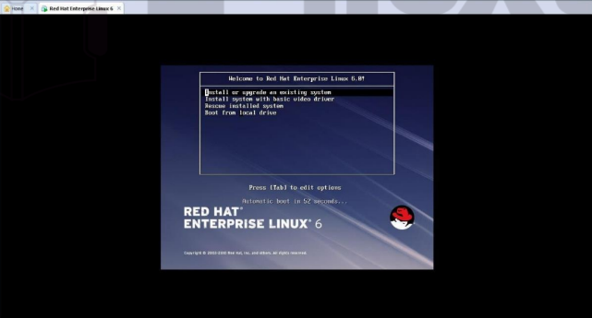

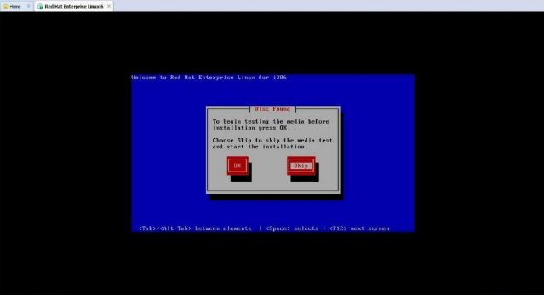

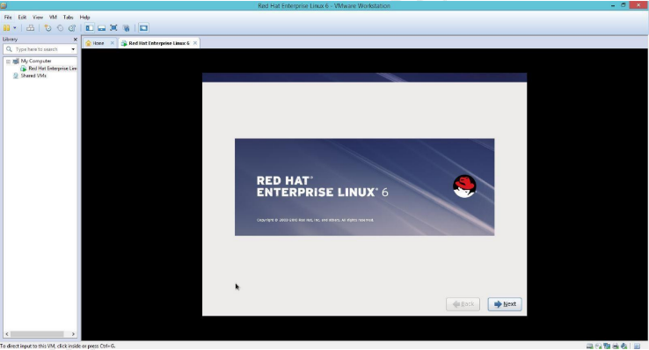

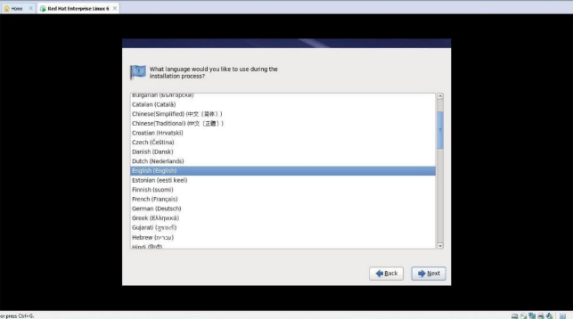

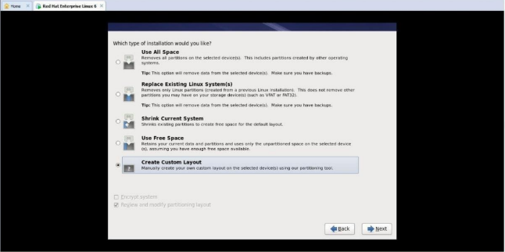

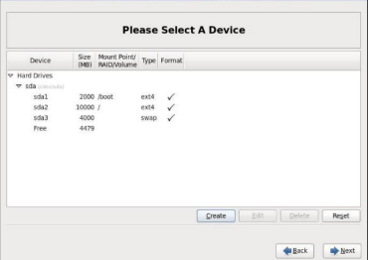

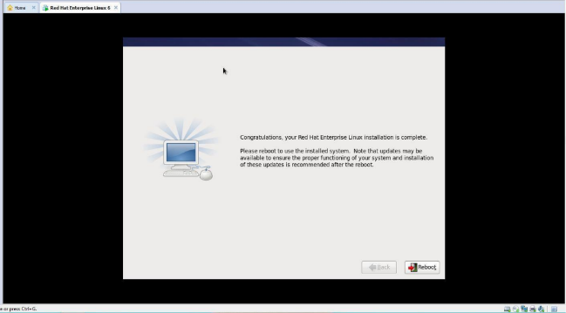

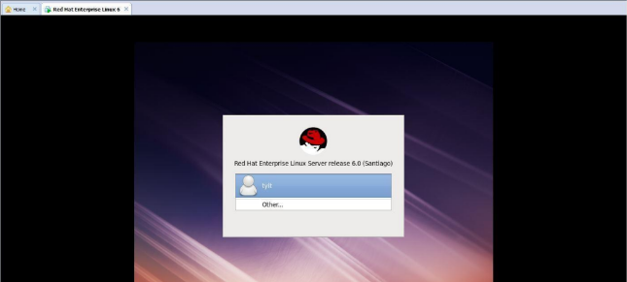

| PRACTICAL NO 1 : Graphical User Interface and Command Line Interface and Processes. |
| --- |

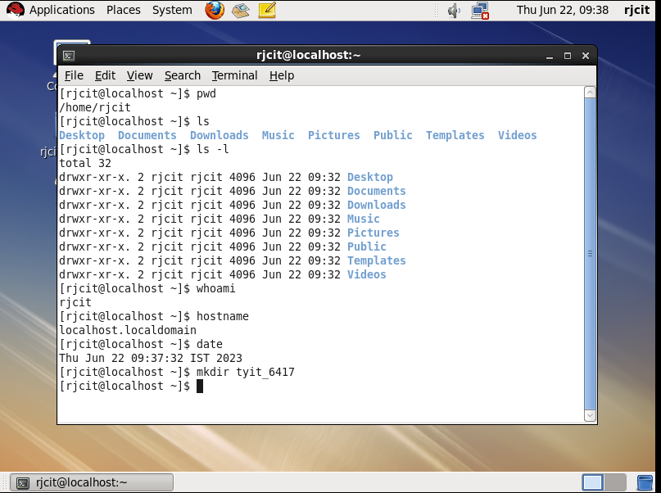

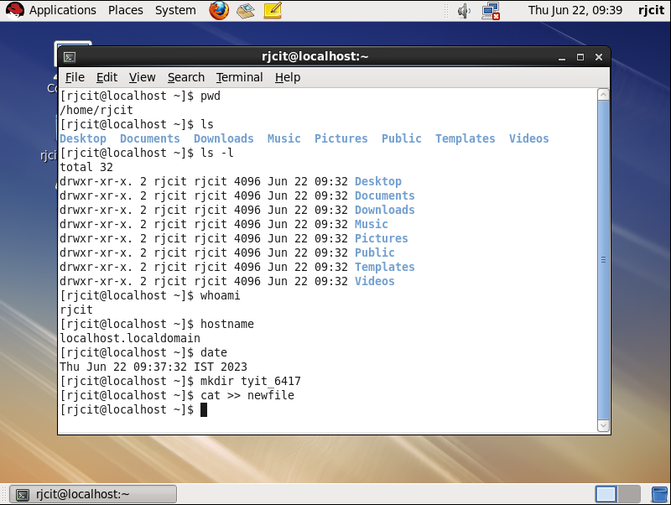

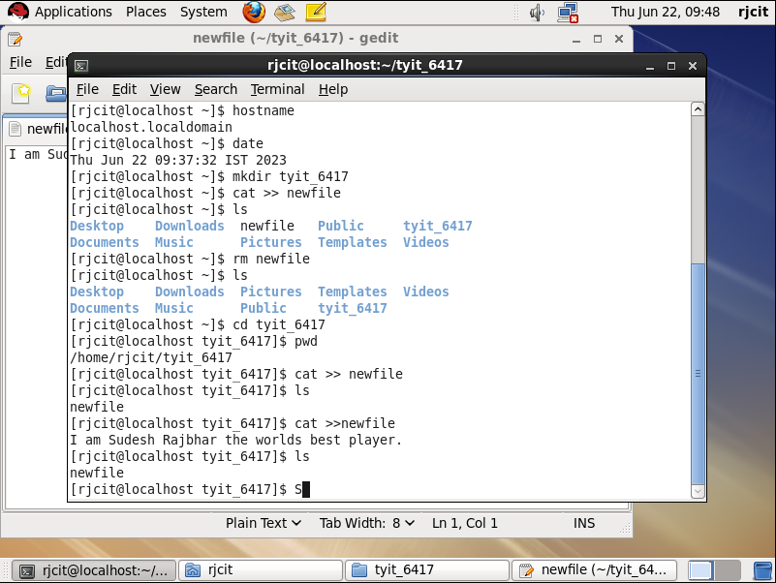

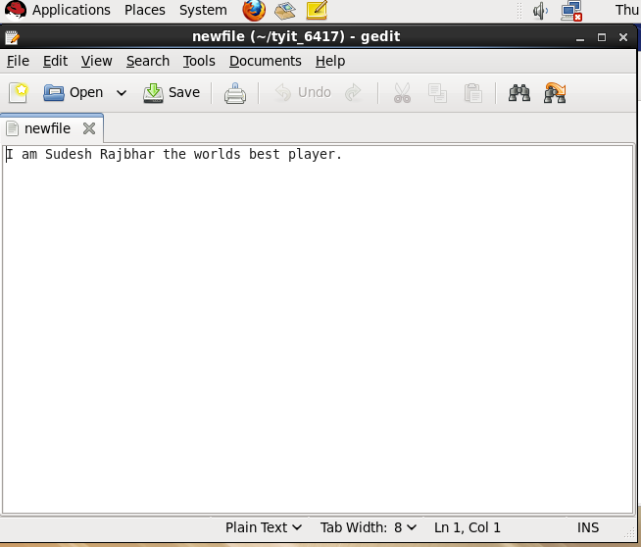

**COPY:**

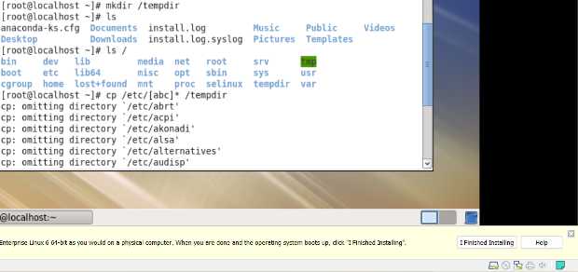

**TIME:**

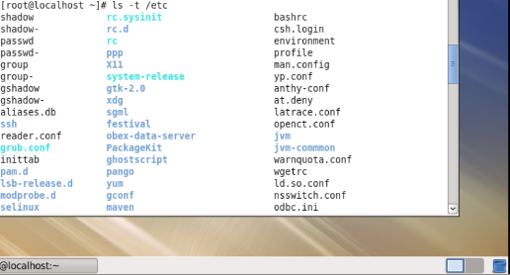

**SIZE:**

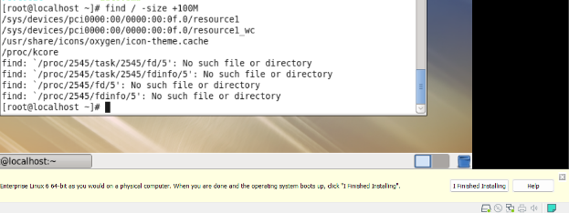

**WHOAMI**:

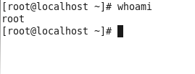

**HIDDEN FILES:**

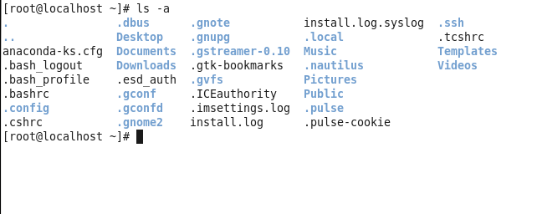

**Hard link and soft link:**

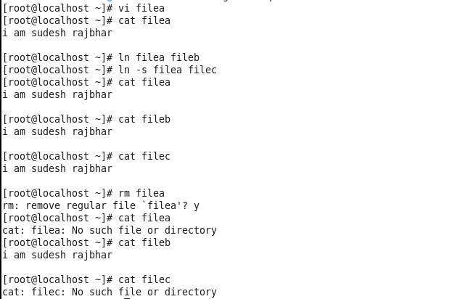

**Ls file selecting:**

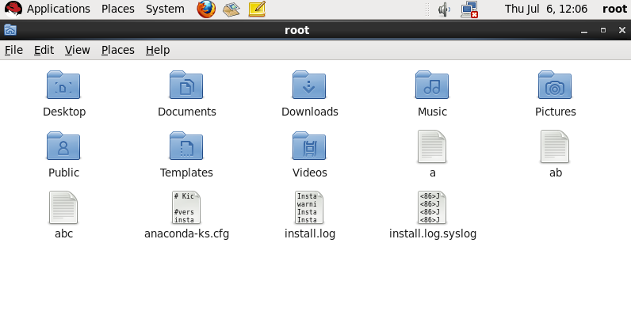

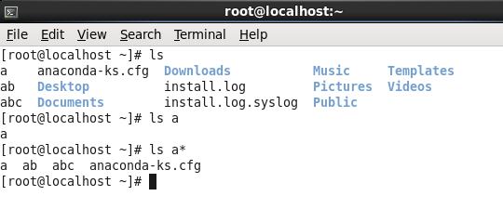

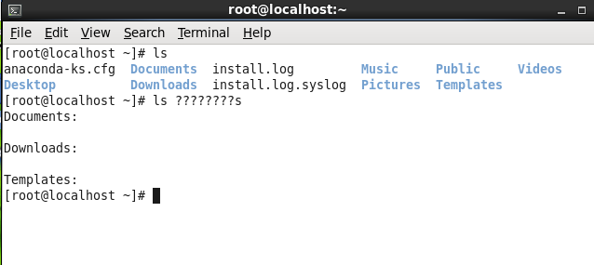

**Cat:**

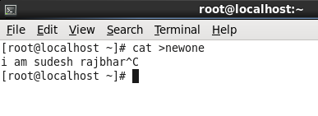

**Vi:**

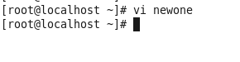

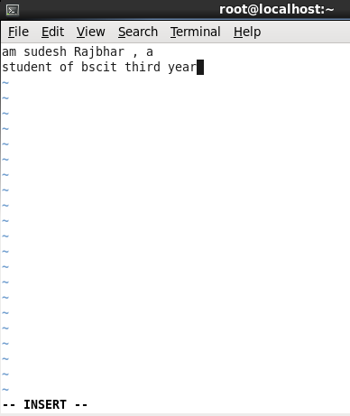

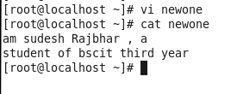

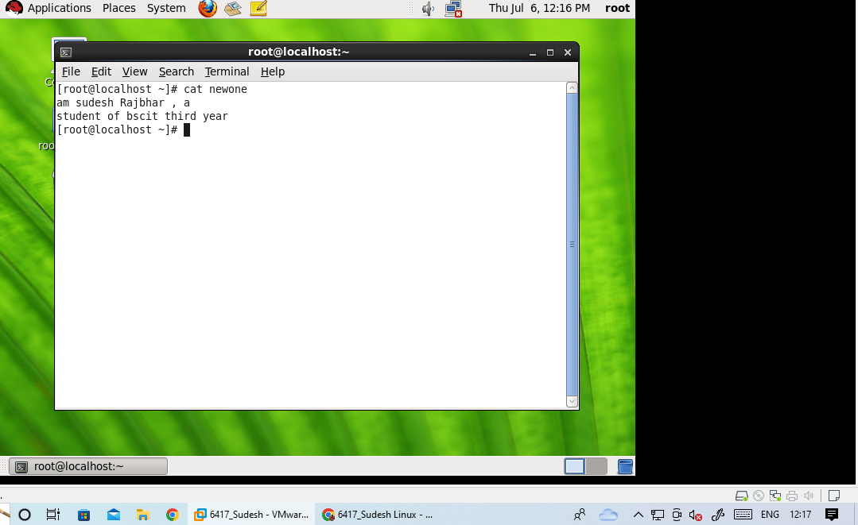

**Cp:**

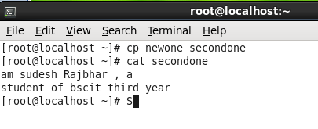

**Mv:**

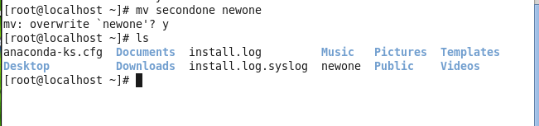

**Ps:**

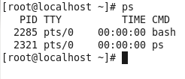

**Top:**

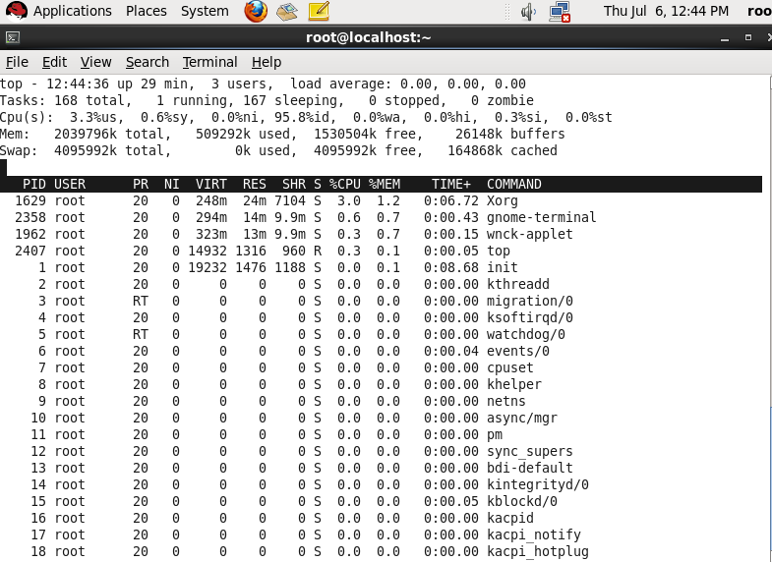

| PRACTICAL NO 2: Working with Partitions and storages. |
| --- |

**fdisk -l:**

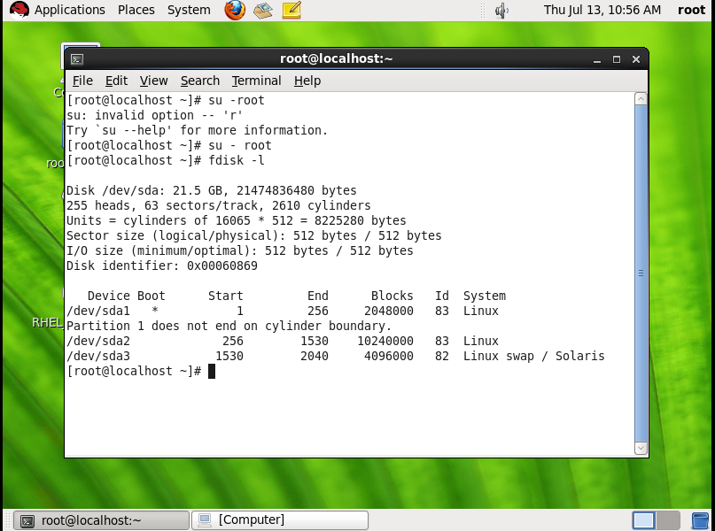

**Fdisk /dev/sda:**

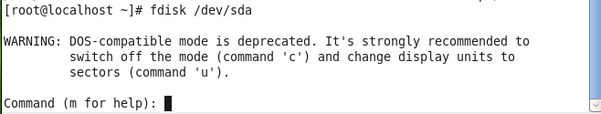

**Creating partitions:**

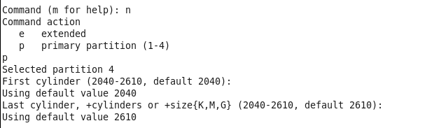

**Partition table entered:**

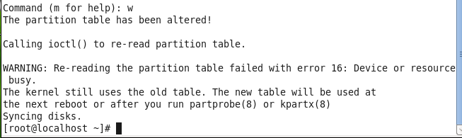

**Partx -a /dev/sda:**

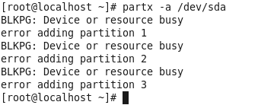

**Partx -l/dev/sda :**

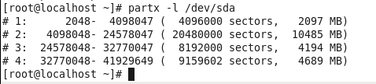

**Mkfs.ext4 /dev/sda4:**

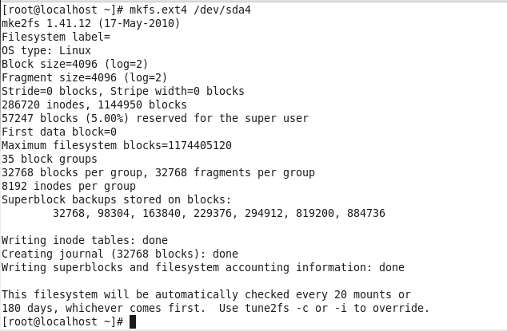

**Mkdir:**

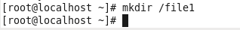

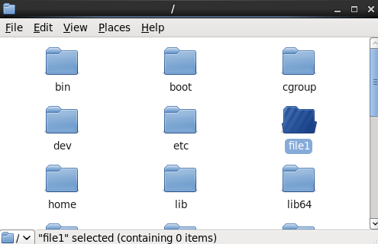

**Vim etc/fstab:**

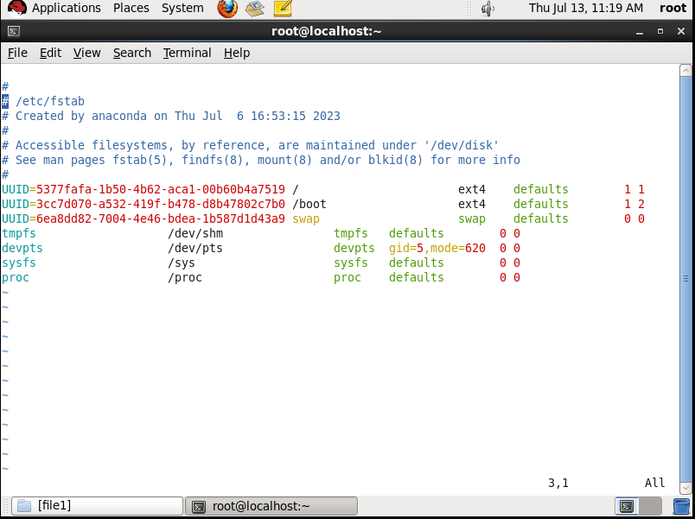

**Adding content:**

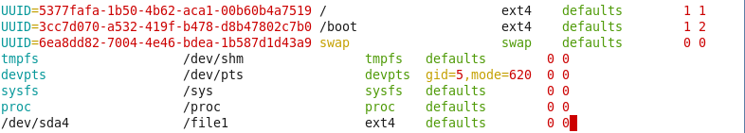

**Mount -a:**



**Df:**

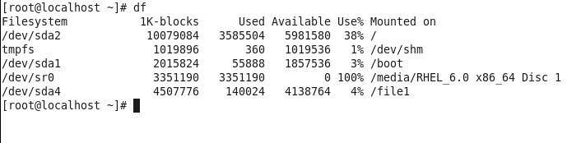

**Df -hT:**

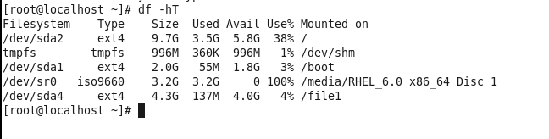

**Umount /dev/sda4:**

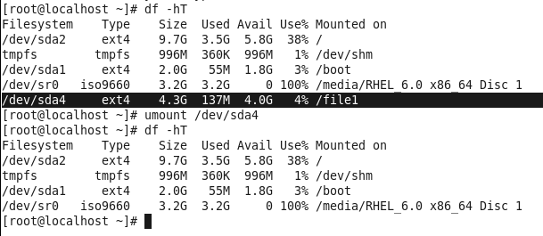

Rmdir /file1:

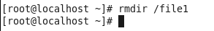

Fdisk /dev/sda:

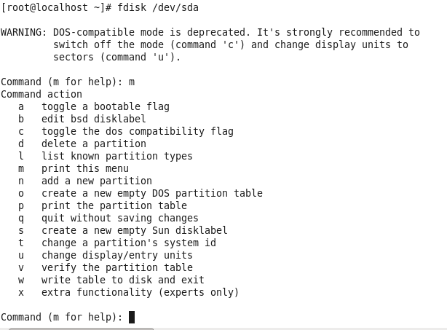

**Deleting partition 4:**

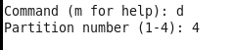

**Again w:**

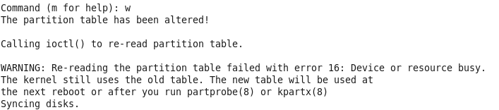

**Partx -a /dev/ssda:**

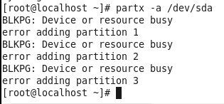

**Partition sda1,sda2:**

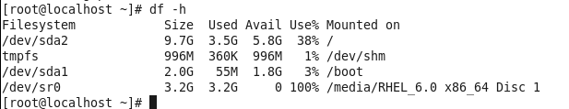

**IN RJCIT:**

**Crontab -e:**

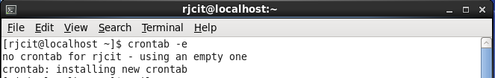

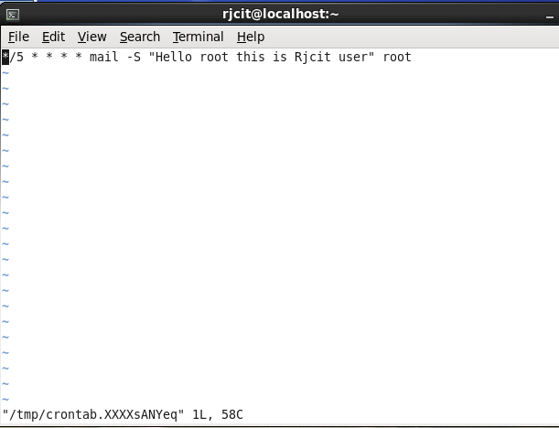

**Mail send to root:**

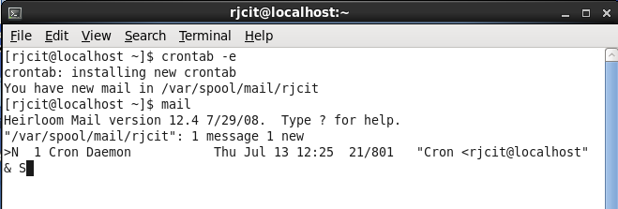

**MAIL arrived in root:**

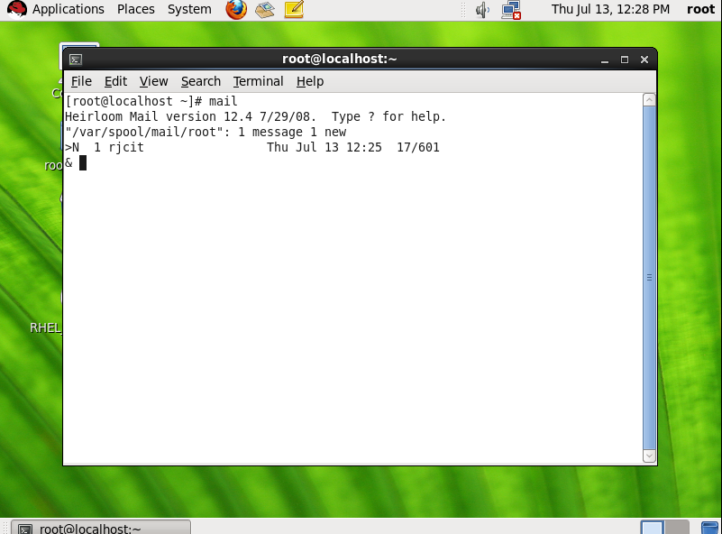

**Next message in 5 min i.e.12:25 thn 12:30:**

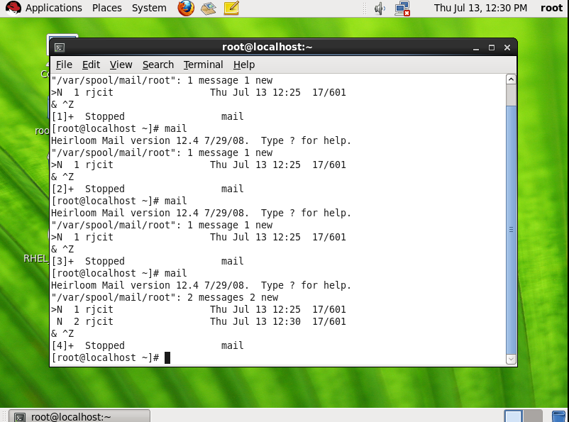

### LVM Partition-3 aug 2023

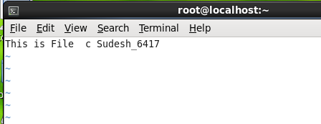



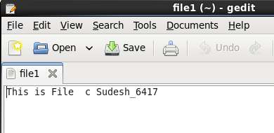

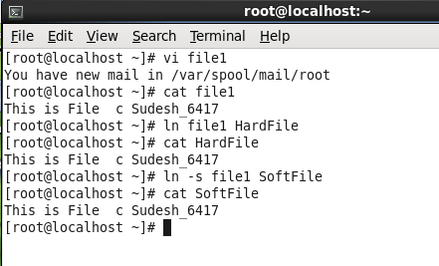

**Create one physical volume /dev/sda5 and one volume group tybscit-A then create one logical volume user1 and mount it on a disk.**

**c**

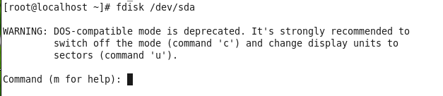

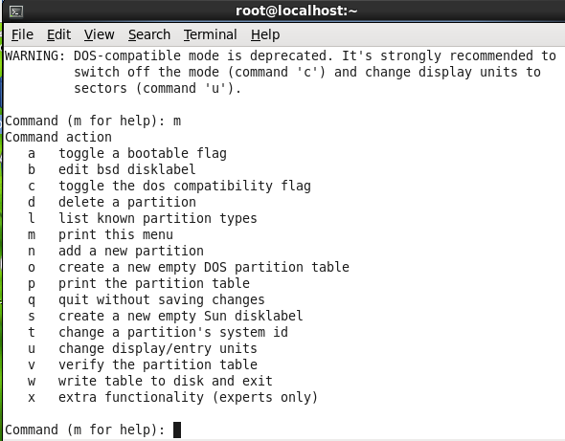

**Create a new partition:**

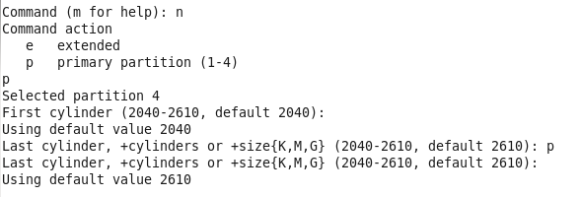

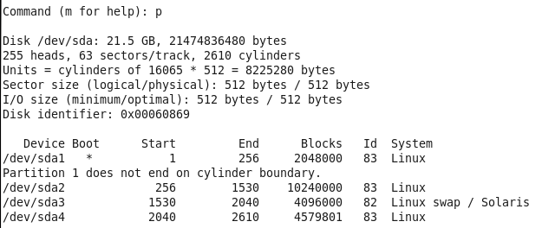

**Type t to change partition id to 8e (lvm):**

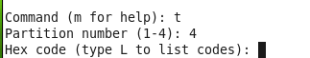

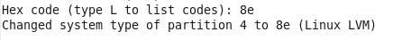

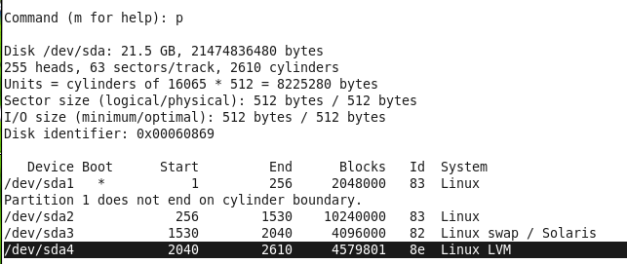

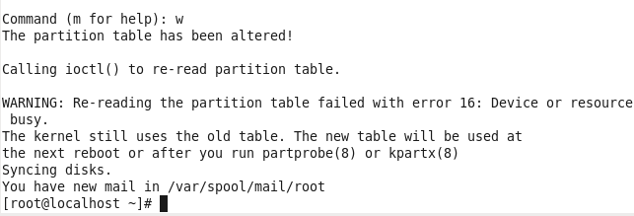

**1)physical volume**

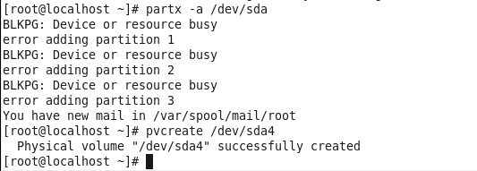

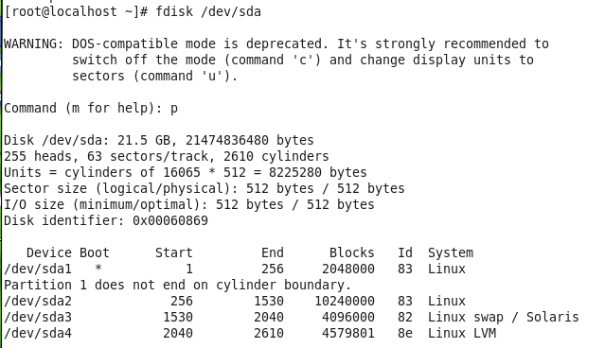

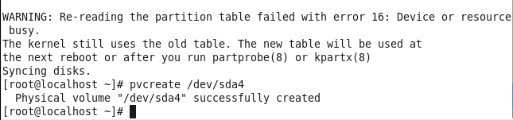

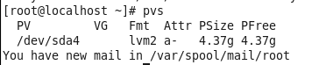

**2)Volume group:**

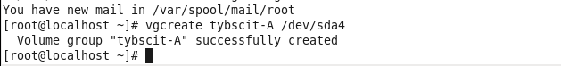

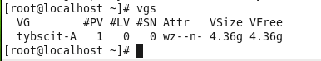

**3)Logical Volume.**

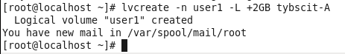

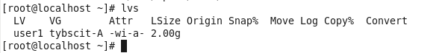

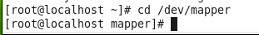

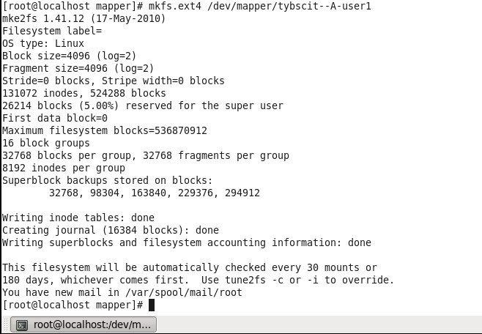

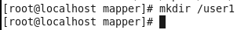

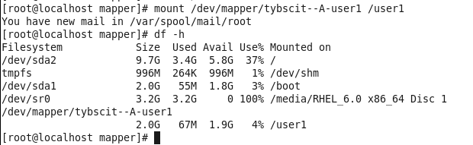

**removed/umount:**

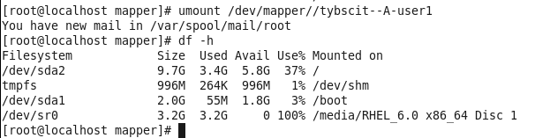

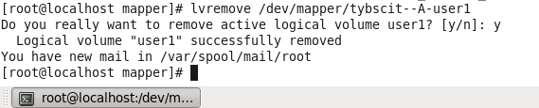

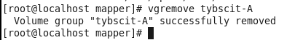

**Creating Repositories:**



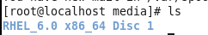

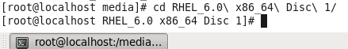

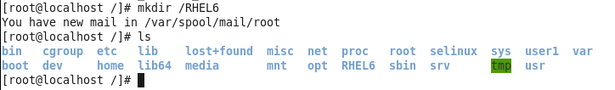



**Copy**

**cd /RHEL6**

**cp -vr /media/RHEL_6.0\ x86_64\ Disc\ 1/* /RHEL6/**



**NETWORKING**:

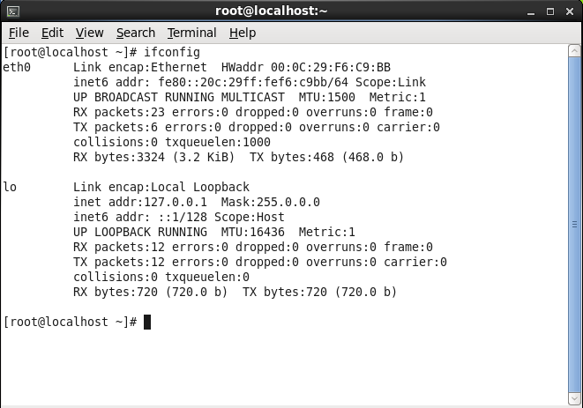

**Add ip address:**

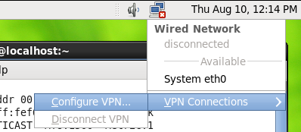

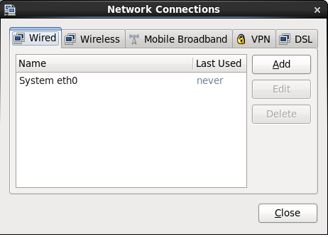

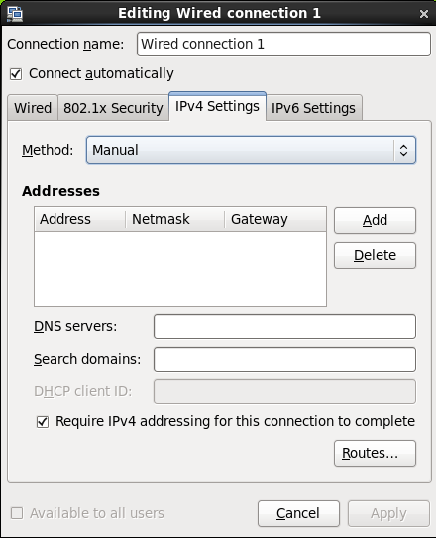

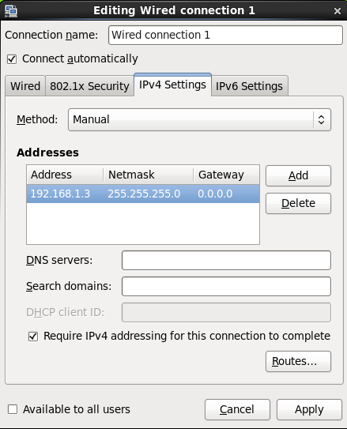



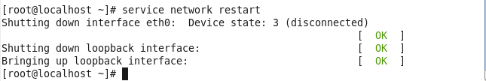



**SHOW IP ROUTES:**

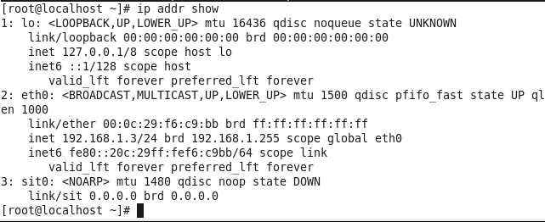

**PING THE NETWORK:**

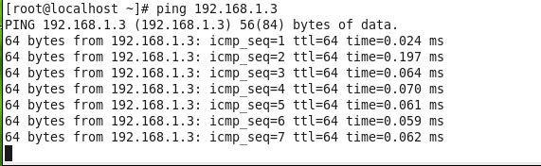

**ADD NEW NETWORK:**

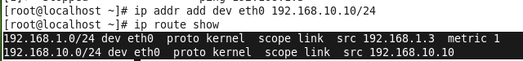

| PRACTICAL NO 4. Working with Users, Groups, and Permissions |
| --- |

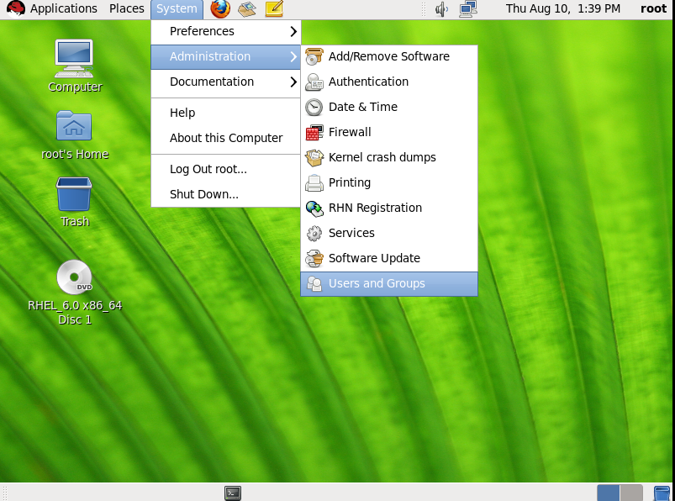

**Add user:**

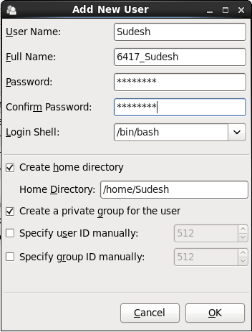

**Add more similarly:**

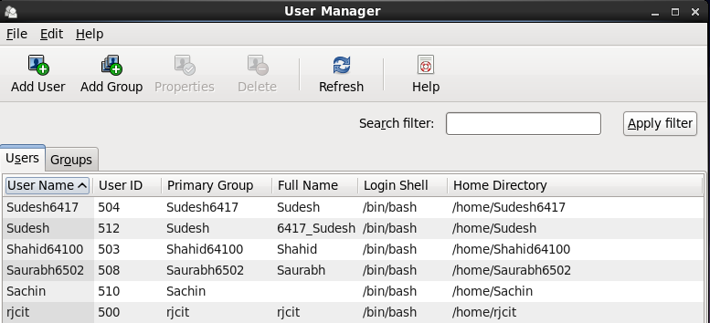

**ADD GROUP:**

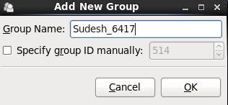

**ADDING USERS:**

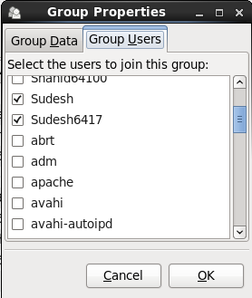



**BECOMING sUPER USER:**

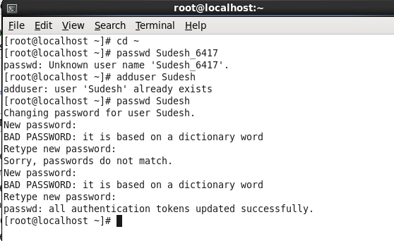

**CHANGE THESES LINES:**

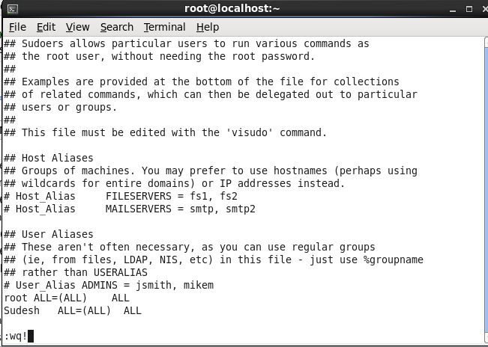

**NOW CHANGE USER AND TRY TO ADD USER AS U ARE A ADMIN:**

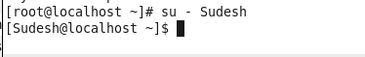

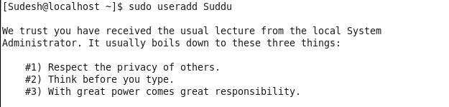

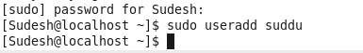

**ADMINISTRATIVE COMMANDS:**

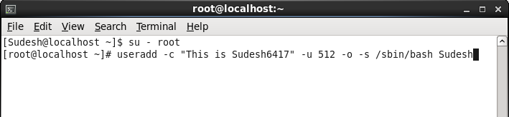



**Add new user:**



**CHAGE:**



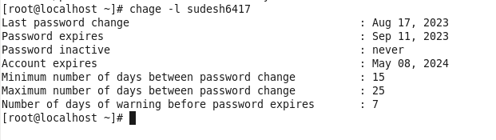

**UNLOCK PASSWORD:**

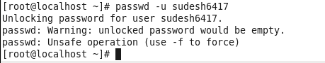

**LOCKING PASSWORD:**

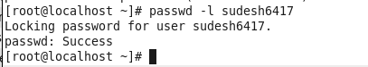

**CHSH COMMAND TO CHANGE SHELL:**

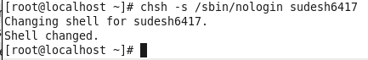

**GROUPADD COMMANDS TO CREATE A NEW GROUP AND ADD USERS AND APPOINT A ADMINISTRATOR.**



**TO SEE ABOVE CHANGES: cat /etc/group**

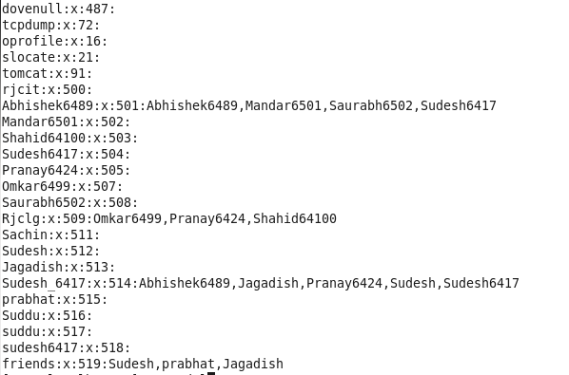

**Delete user:**

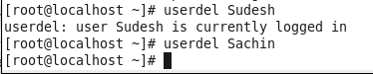

**Delete group:**

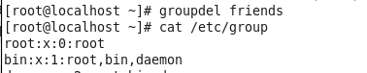

| PRACTICAL NO 5 : Firewall and cryptographic services. |
| --- |

**Stop services:**

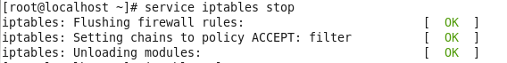

**List :**

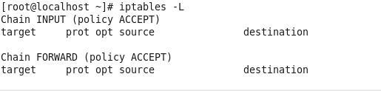

**Iptables command to accept connection as default:(accept)**

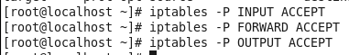

**Iptables command to accept connection as default:(drop)**

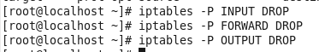

**Iptables command to accept connection as default:(reject)**

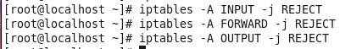

**Iptables -L to check connections:**

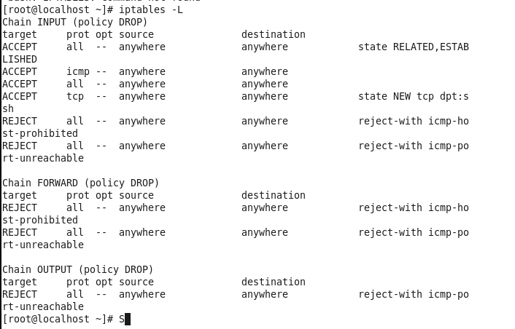

**Accept host with IP ADDRESS 192.168.1.5**



**Block all connections coming to port 22.**



**Allowing all incoming ssh connections:**



**Allowing outgoing ssh connection for specific address**



**Allowing outgoing ssh connection which established for incoming ssh connection request.**



**Iptables for incoming ping request**



**To drop all outgoing telnet connection**



**To Reject all incoming telnet connection**



**Iptables to reject all incoming traffic except ssh & local connection**

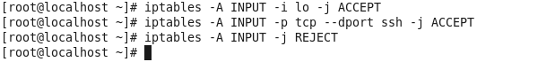

**Iptables to drop all the incoming connections on a specific network interface**



**Iptables -L: to show all the work done by above commands.**

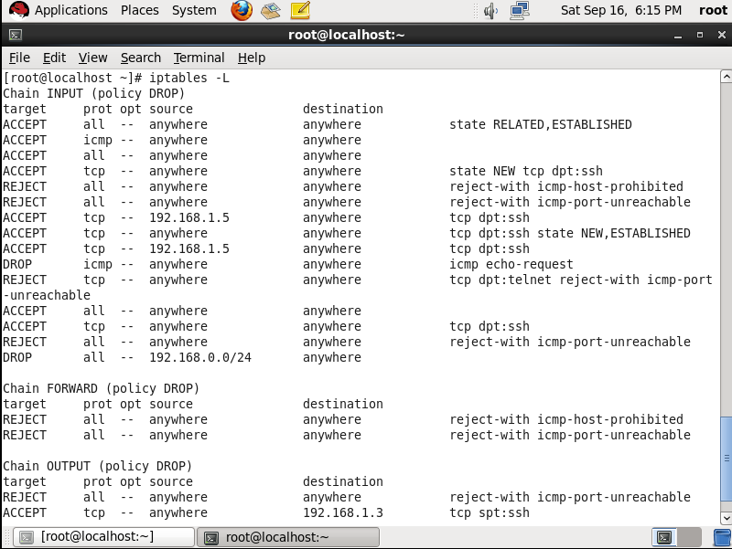

**To Flush all the rules -Iptables -F**

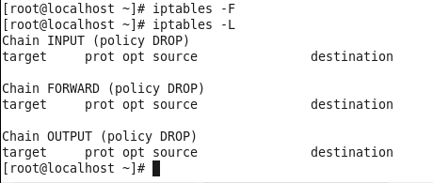

| PRACTICAL NO 6.Setting up File server |
| --- |

1. **Setting up Samba Server.**

**Open Windows Network Connections Folder through this path**

**“Control Panel\Network and Internet\Network Connections”**

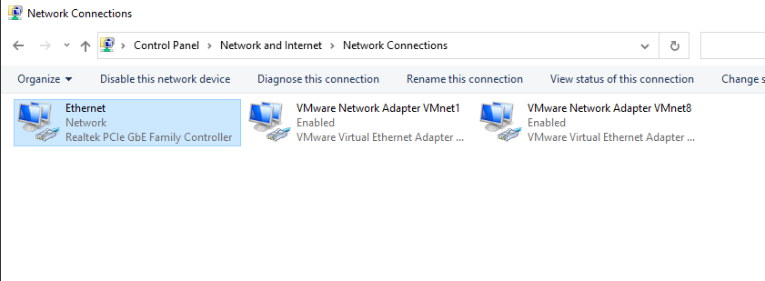

**Click on Windows Connected Internet Service.**

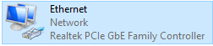

**Click on Details... To view the System IPv4 Address “192.168.1.10”.**

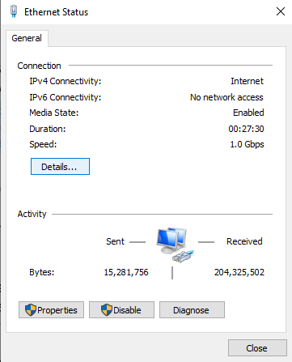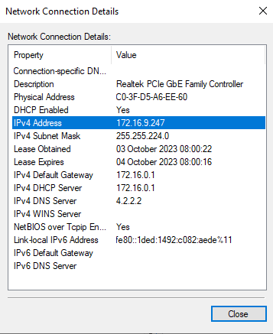

**Now, Open The VMware Network Adapter and click on Properties.**

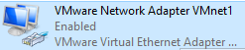

**Now click on Internet Protocol Version 4 and set the below lines as follow:**

**IP address: 172.16.9.248**

**Subnet mask: 255.255.224.0**

**Default gateway: 172.16.0.1**

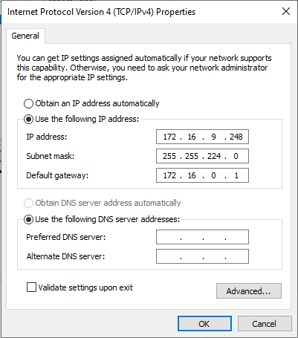

**Now, Switch on the Linux Machine on VMware and set the IP address for it.**

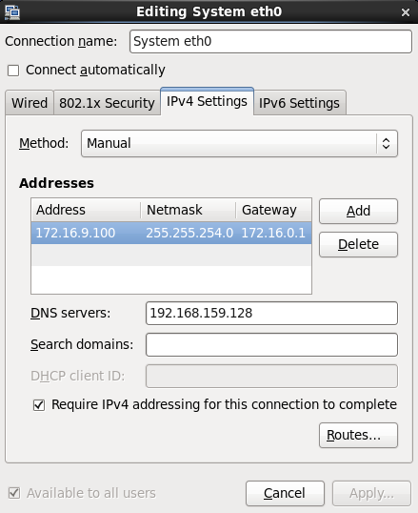

**Ifconfig: to check the ip address of the system.**

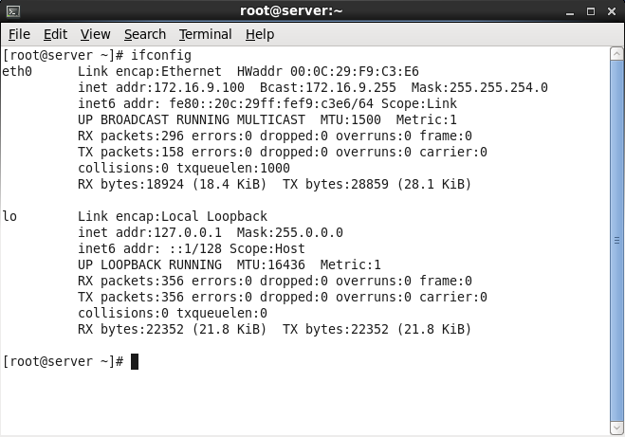

**Go to the packages directory**

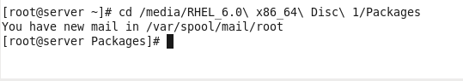

**Install all samba packages.**

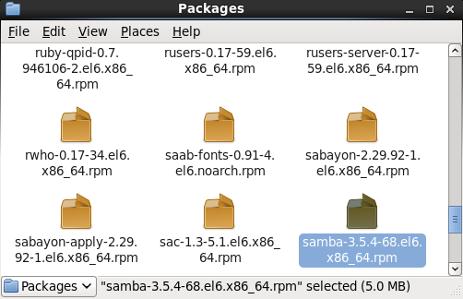

**Check whether the samba package is installed or not.**

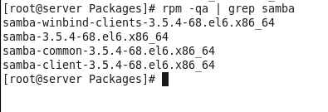

**Create a Samba user account that has access to the share.**

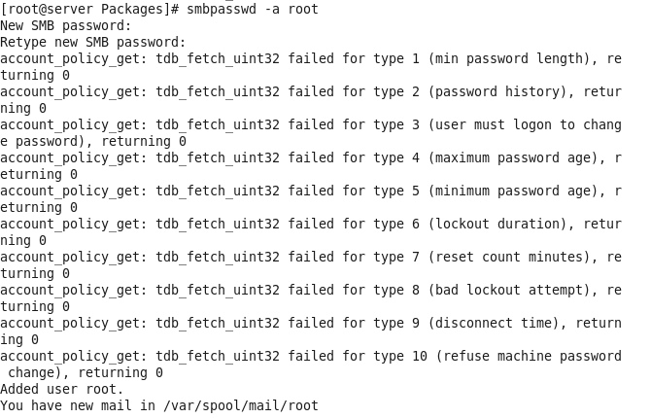

**Create a directory /data on the Linux file system on the Samba server.**

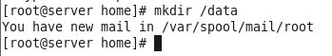

**Change directory as data.**

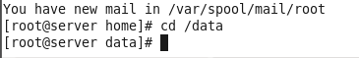

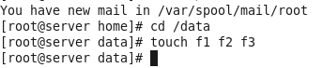

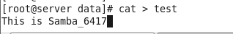

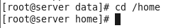

**Give full permission to this directory then, Set directory with the samba share t type, if you want to treat the files as samba share data.**

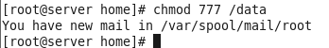



**Open smb.conf file with vi editor.**



**Add the below data at the end of the file:**

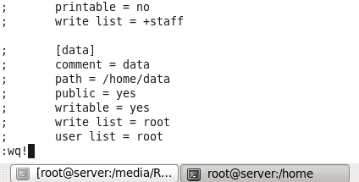

**Restart the smb service.**

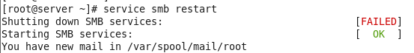

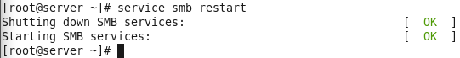

**Go to Firewall: System => Administration => Firewall.**

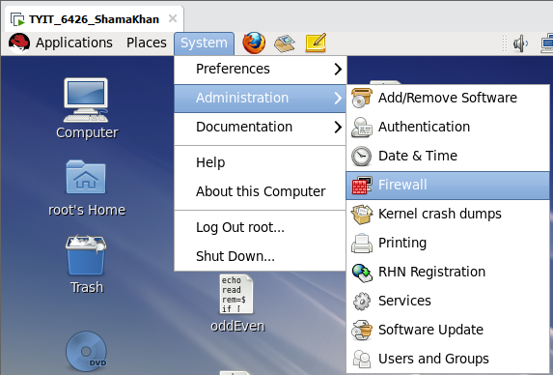

**Turning off the firewall by clicking on Disable then clicking on apply to make changes.**

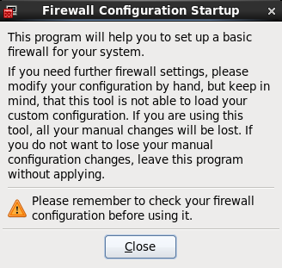

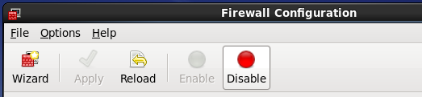

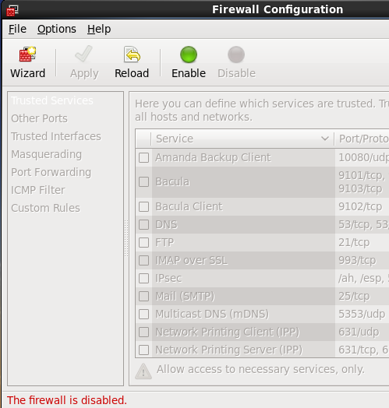

**Now, try to ping the ipaddress of the system to receive the packets from Windows Server.**

**Ping 172.16.9.100**

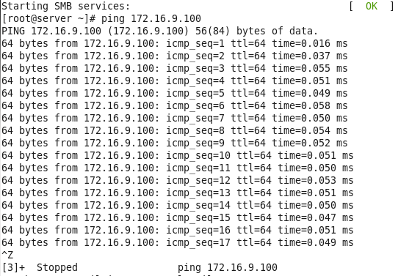

**On Windows Server, open the run command by pressing “Windows + r”.**

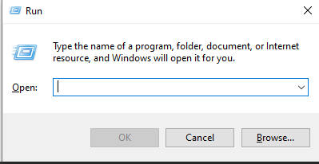

**Type ping ipaddress of the Windows System to receive packets from VMware Networks.**

**Ping 172.16.9.100 -t**

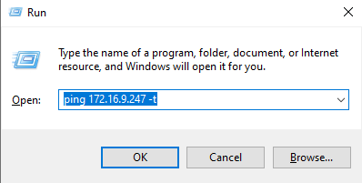

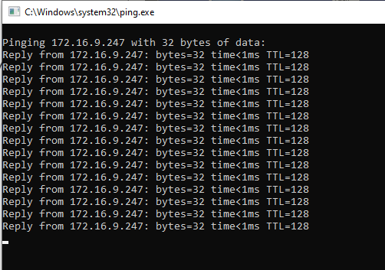

| PRACTICAL NO 7 : Configuring DNS Server |
| --- |

* **Name address resolution is simply the conversion of people friendly names**

**into computer friendly numbers.**

* **It means that every interface on the network has a unique group of numbers**

**called as IP address.**

* **These group of numbers present to the computers in the network but it is**

**difficult for the users to by heart, learn or remember them.**

* **DNS makes possible for the users to enter the names and then thes4e names**

**get converted into numbers.**

* **The main function of name address resolution is to create an efficient user**

**and computer interaction.**

* **For this name address resolution there is need that how to install and**

**configure the Domain Name System.**

* **To understand, take a look at the domain and understand its working. For**

**eg. example.com.**

* **In the above eg: The first part of the domain name is the name of the**

**company or institution or an organization. The next part after the period/dot**

**is called a top-level domain (TLD).**

**There are many TLD listed below**

**.com - A TLD used to register a business**

**.edu – A TLD for educational institution**

**.name – A TLD used to register sites for individuals**

**.gov – A TLD given to government**

**.mil – A TLD used for military**

**.org – A TLD used by a non-commercial organization**

**Following files are used while Configuring DNS Server.**

* **named.conf – It is main Configuration file that contains global properties**

**and other sources. It is found in / etc/ directory.**

* **named.ca – The file contains the name and address of root servers. Used**

**for the purpose of caching the forward zone. It is found in /var/named.**

* **named.local – The file provides information for resolving the loopback**

**address for the local host. Also called as named.empty, used for the**

**purpose of caching of reverse zone.**

**It is found in /var/named/**

**The 2 additional files required for the master domain server are:**

**(i)zone – This file contains the names and addresses of hosts in the localdomain**

**and maps names to IP addresses.**

**(ii)reverse.zone – This file provides information to map ip-address to names Hence**

**reverse.**

1. **Ifconfig**

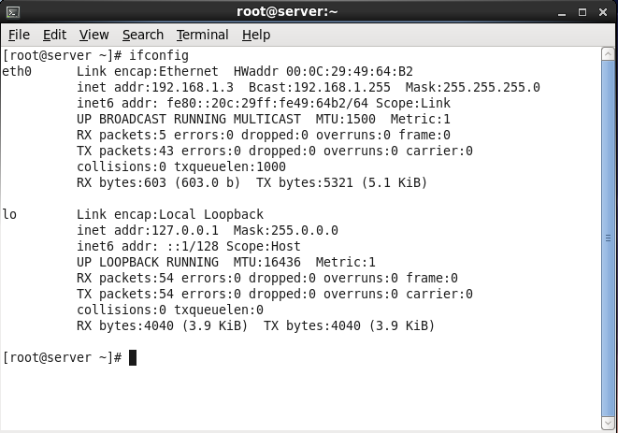

1. **Type vim /etc/sysconfig/network-scripts/ifcfg – eth0- ADD DNS1 AND HWADDR from if config, at the end do only w! And then q!.**



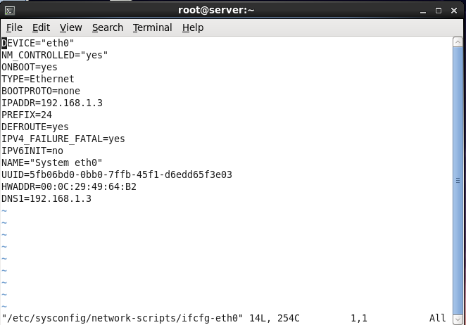

**3)vim /etc/hosts**

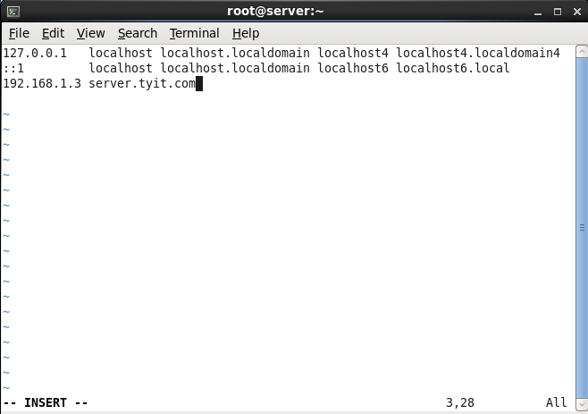

**4)vim /etc/sysconfig/network**

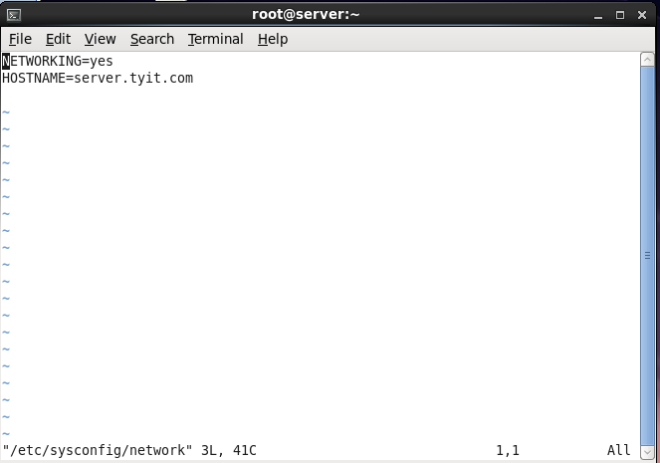

**5)vim /etc/resolv.conf**

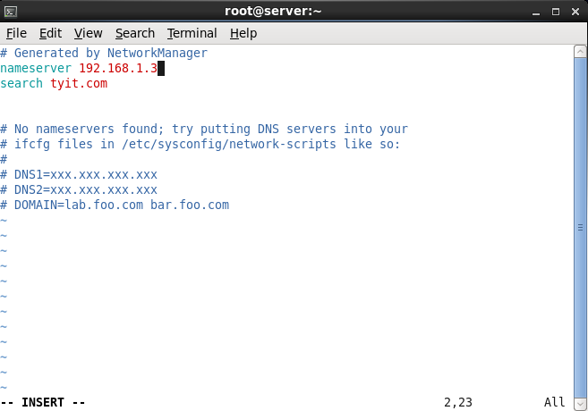

**6)**

**Service network restart**



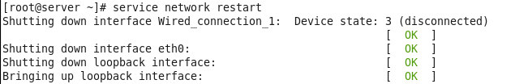

**7)**



**8)install all bind packages.**



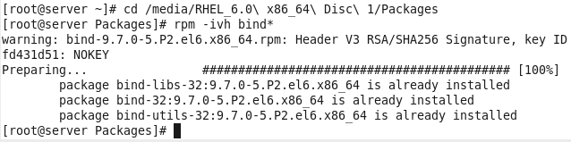

**9)**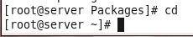

**10)**

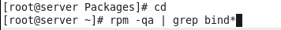

**11)**

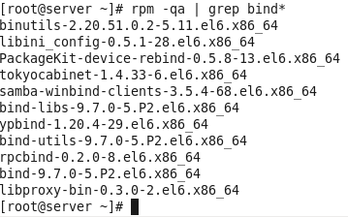

**12)**



**13)**

**Press esc type : se nu**

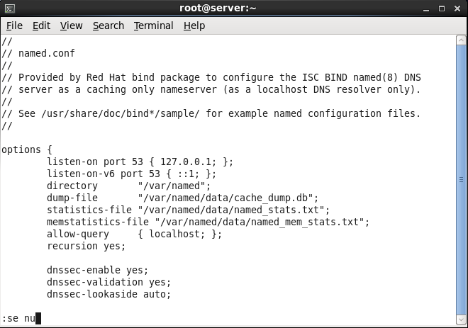

**Change foll:**

| **Type at last: : allow-query { any; };**  **For commenting the listen on port v6 line : put # Sign in front of it.** |
| --- |

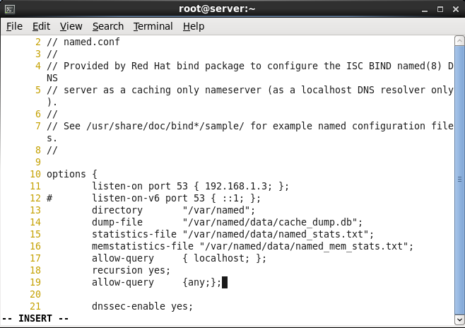

**Last line : /etc/named.rfc1912.zones**

**14)**

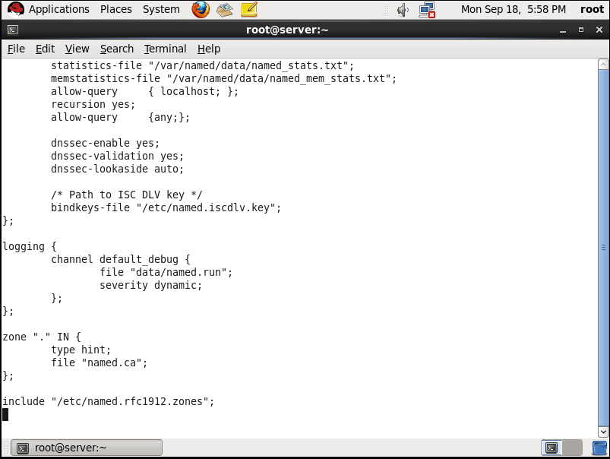

**15)open vi /etc/named.rfc1912.zones**

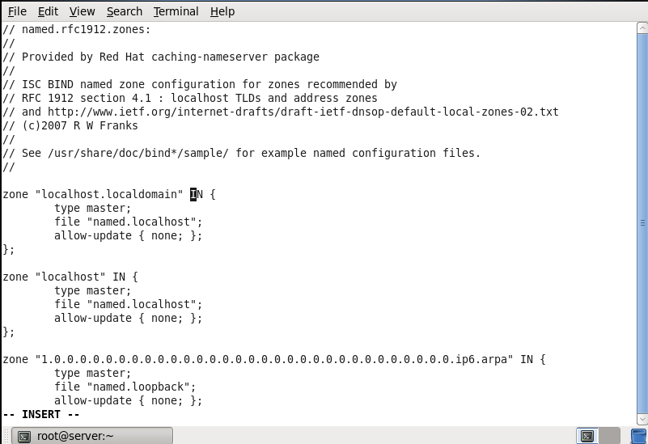

**16)**

**Change localhost.localdomain to tyit.com/named.localhost to forward.zone**

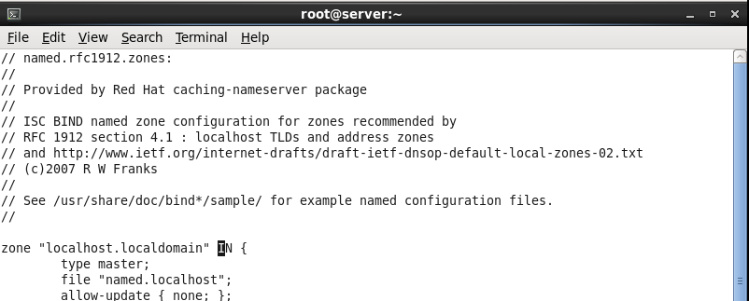

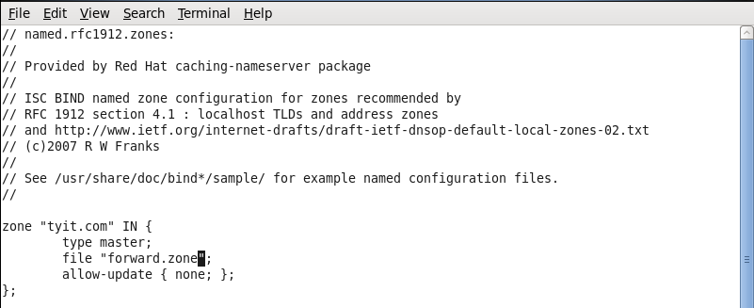

**17)change 1.0.0.127 to 1.168.192.in/named.loopback to reverse.zone**

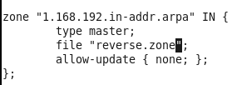

**18)**

**19)**

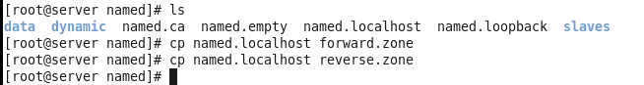

**20)vi forward.zone**

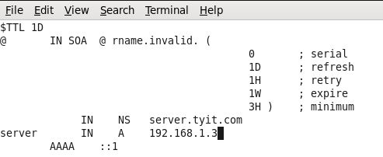

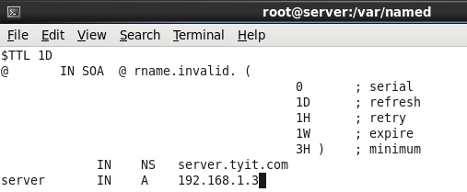

**21)vi reverse.zone**

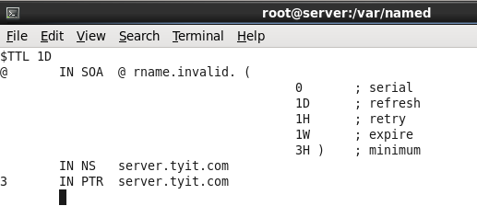

**22)**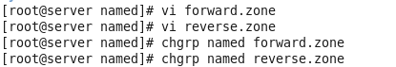

**23)**

| PRACTICAL NO 8 : Setting up a mail server |
| --- |

**a)Configuring mail using mutt**

**Go to this file:**

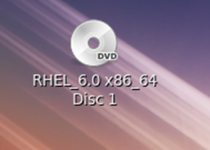

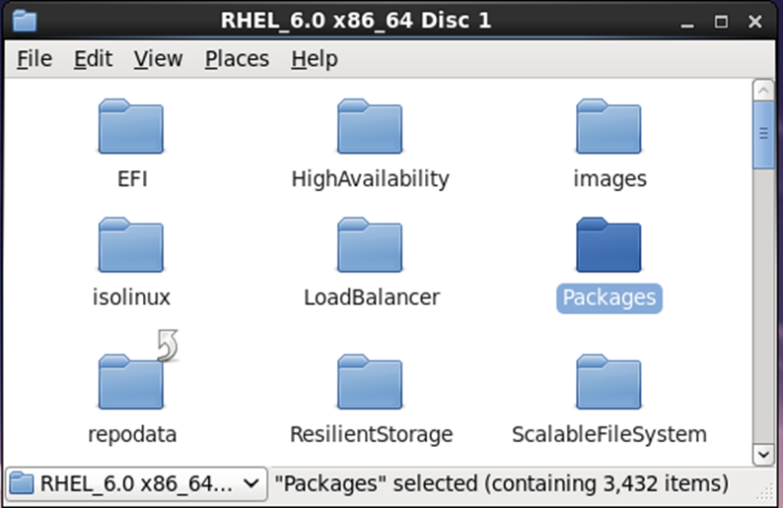

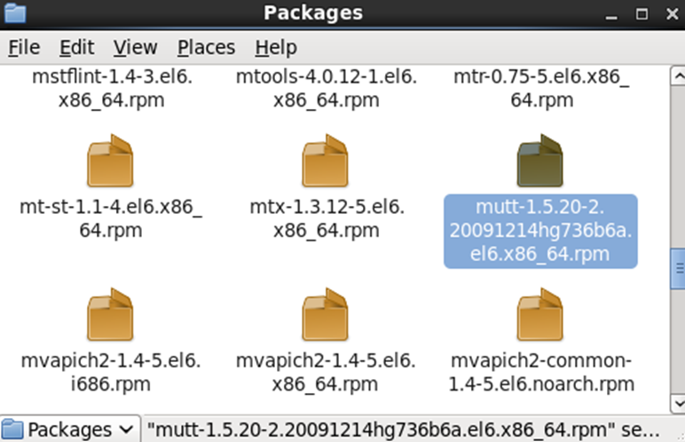

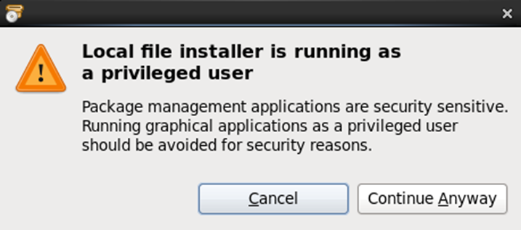

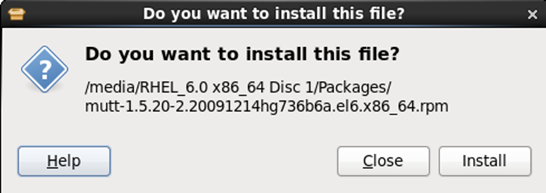

**To check whether installed or not:**

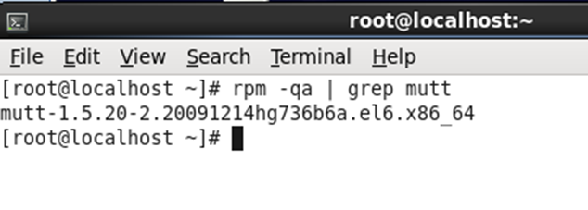

**Now we will create a additional user to send mail to root**

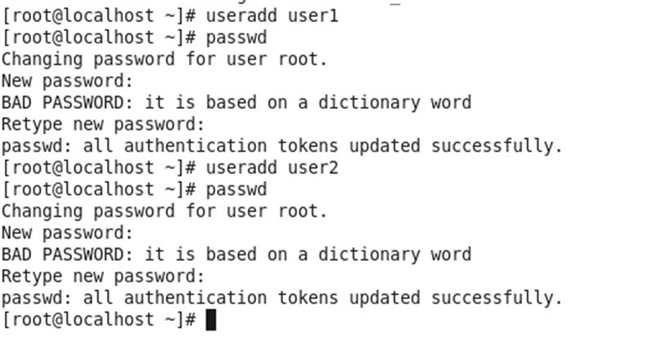

**Switch to user1:**



**Send mail to root:type message/ Ctrl+d to save and quit**

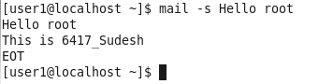

**Switch to root and type mutt**

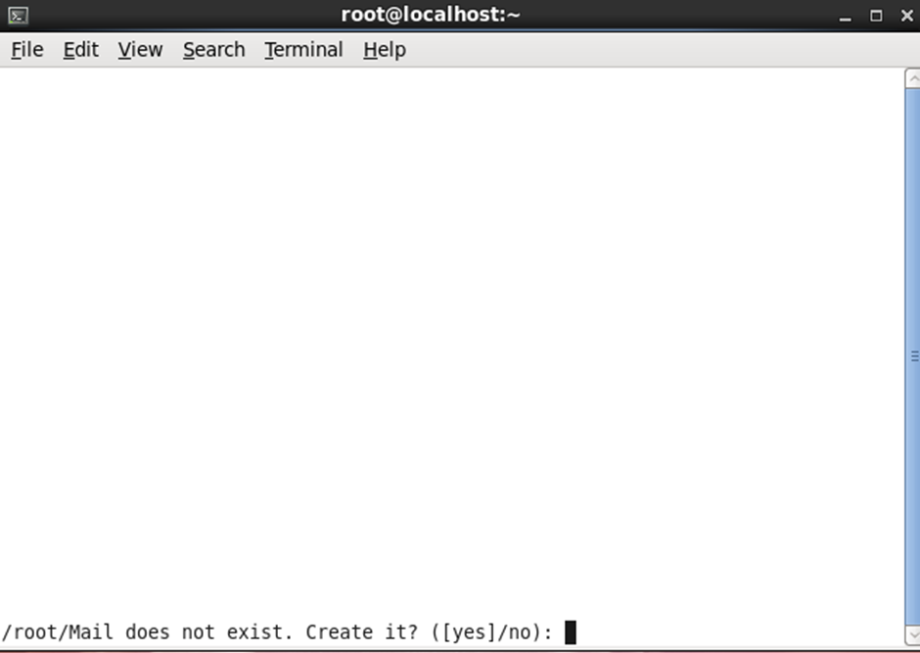

**We can see the mail:**

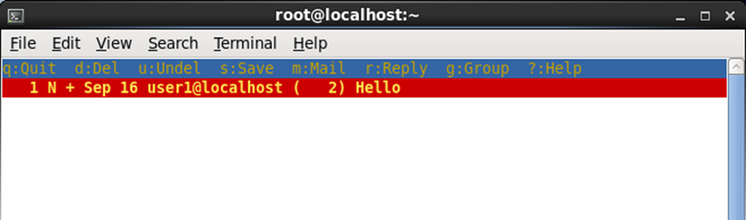

**Mail obtained**

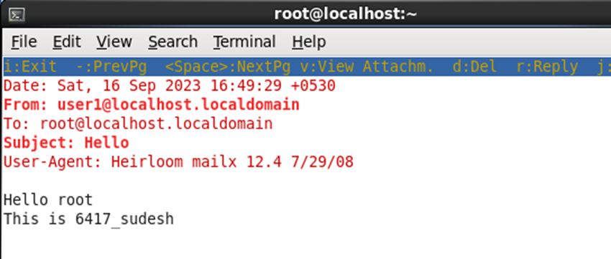

**Reply r and enter**

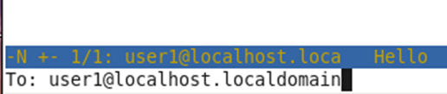

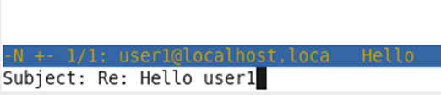

**Type back to user1**

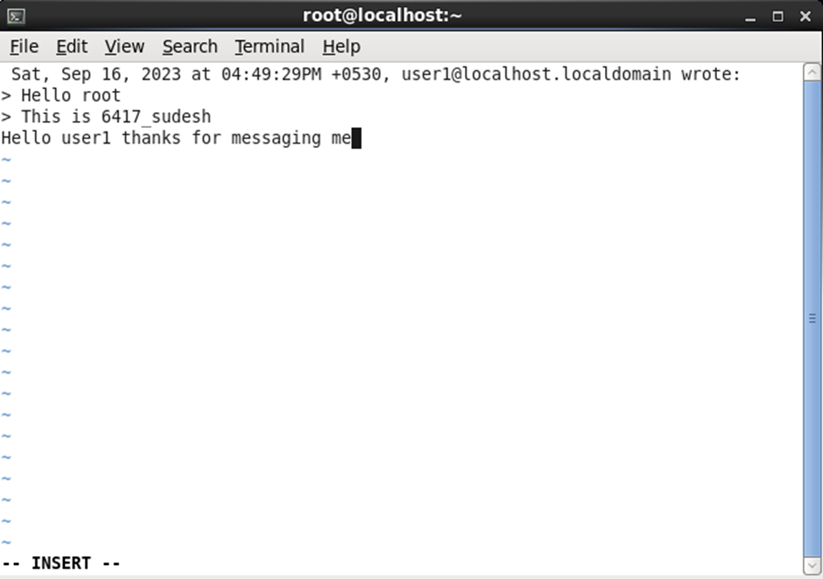

**Esc and :wq! To save**

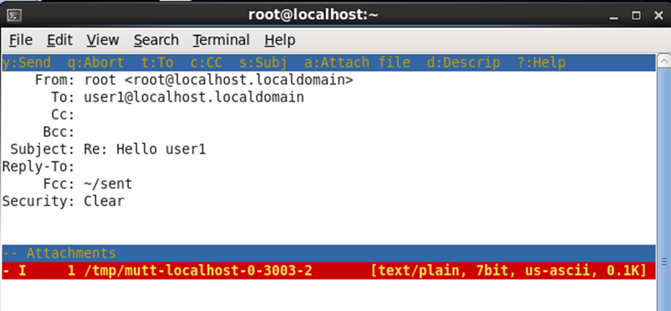

**Type y to send message**

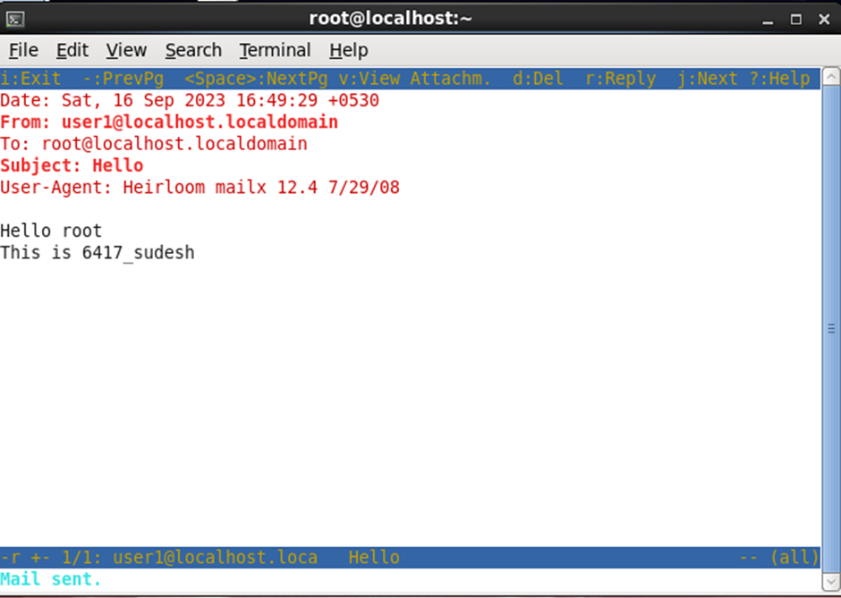

**Switch to user1 again**

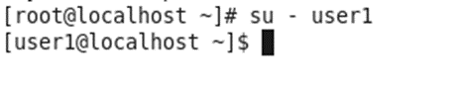

**Type mutt and yes**

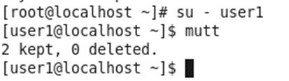

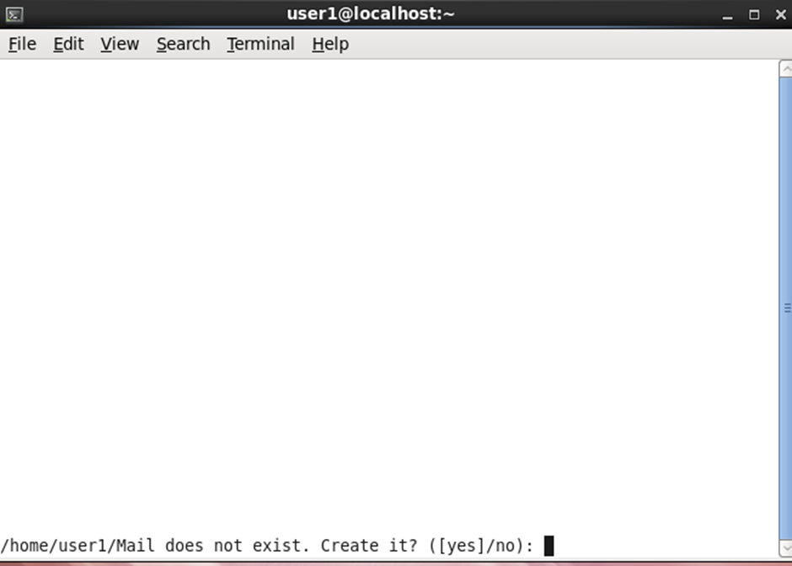

**See the messages**

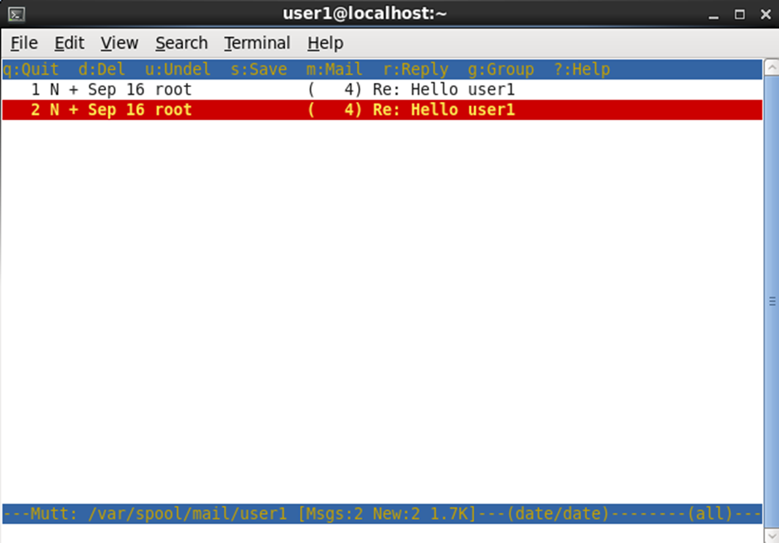

**Mail obtained:**

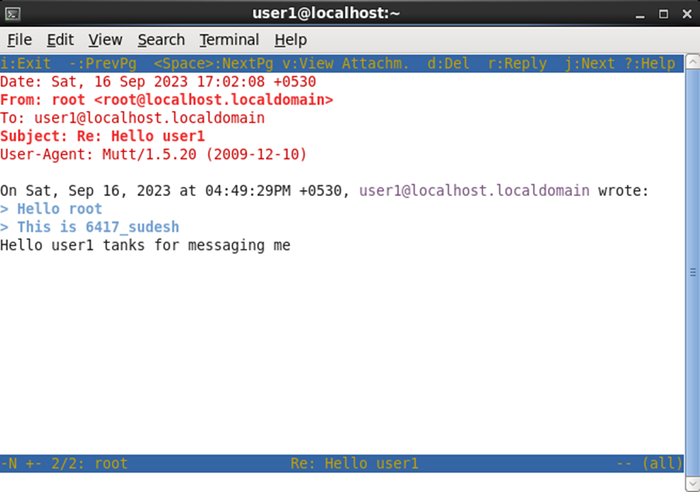

| PRACTICAL NO 9 :Configuring booting with GRUB. |
| --- |

**Install the Grub package from the packages folder by searching “grub”.**

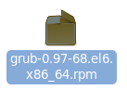

**Open grub configuration file in the “/boot/grub/grub.conf” directory.**

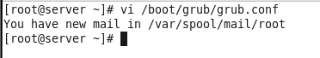

**Copy the last 6 lines from title Red Hat Enterprise Linux and paste it below and make some changes**

**in it.**

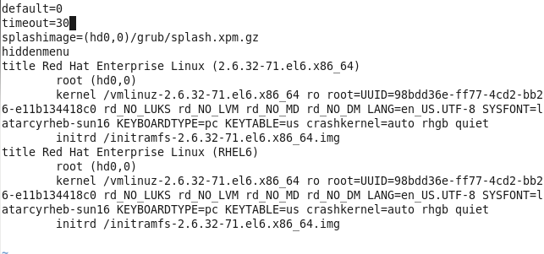

**Only change the title as shown below.**



**Also change the timeout service.**

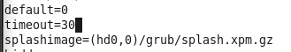

**Increase it by 30.**

**Restart the Linux environment by using “init 6”.**

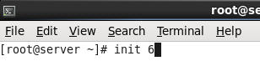

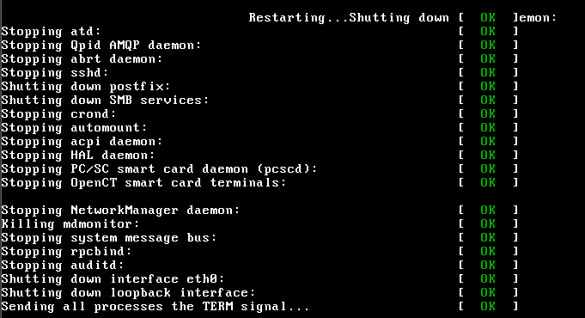

**After restarting we can see there is a 30 seconds timeout shown at last of the 2nd sentence.**

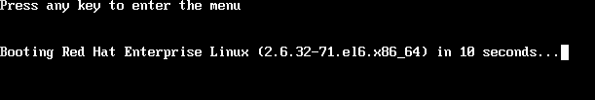

**By pressing any key it will ask about which environment do we want to run.**

**As we can see both the grub entries are shown below**

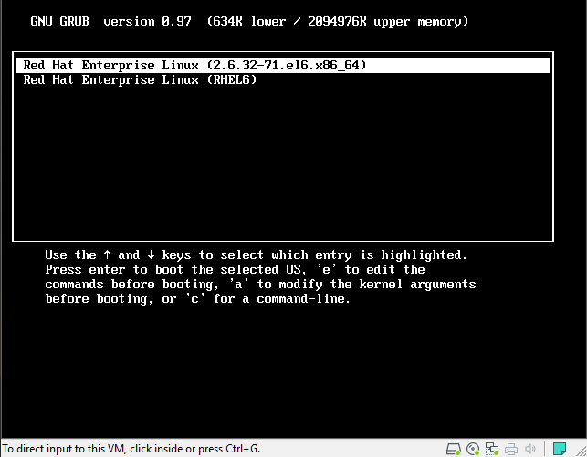

**By up and down arrow we can select the environment which we want to run.**

**By pressing enter on our new environment which we have created by name “My Client Machine.”It will open the same environment as of the Red Hat Enterprise Linux, it means the environment it**

**working correctly.**

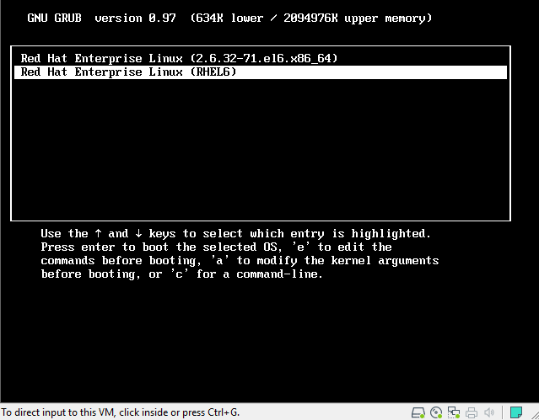

| PRACTICAL NO 10 : Working on Shell-script |
| --- |

### Write a program to find whether a number is positive or negative

**Prepare a script:**

| **Vi Prog1** |
| --- |

**Script Code:**

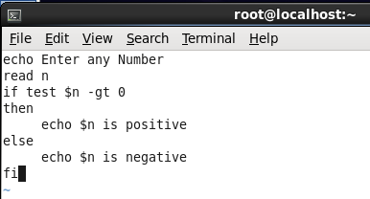

**Execute file:**

| **Chmod +x Prog1** |
| --- |

**Run the Program:**

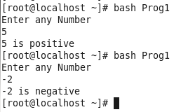

### Enter a Program to find out which number is bigger from two numbers:

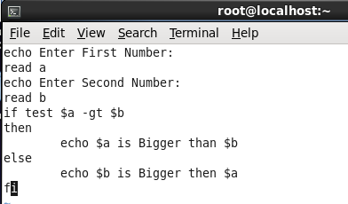

**Now type chmod+x Prog2 to execute and run by bash:**

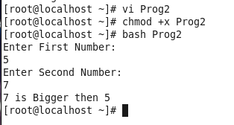

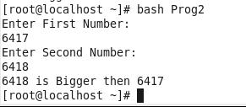

### Write a program to check whether a number is even or odd:

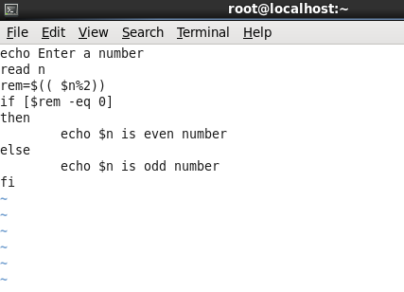

**Output:**

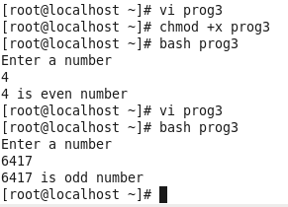

### Write a program to check vowels or consonants.

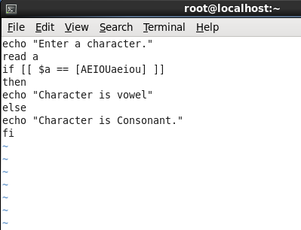

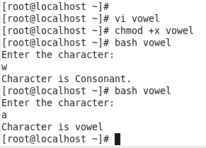

### Write a program to check whether a year is a leap year or not .

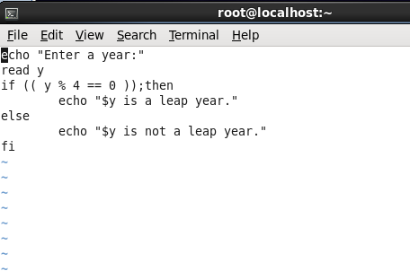

**Output:**

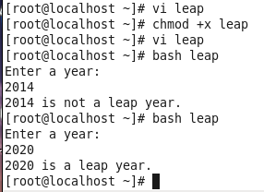

### Write a program to calculate profit and loss.

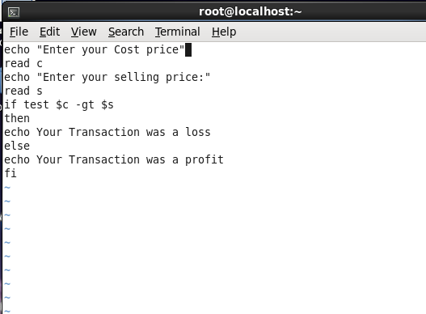

**Output:**

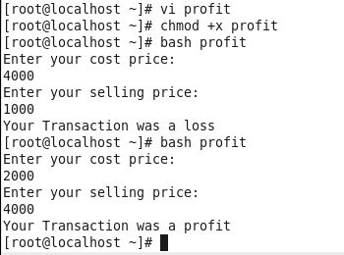

### Write a program to check whether a file exists or not.

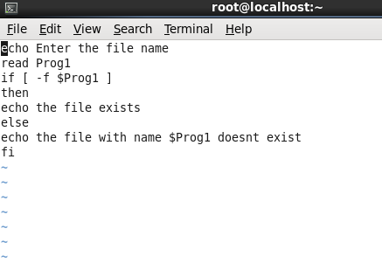

**Files in root folder:**

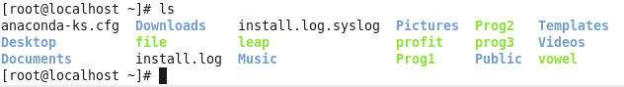

**Output:**

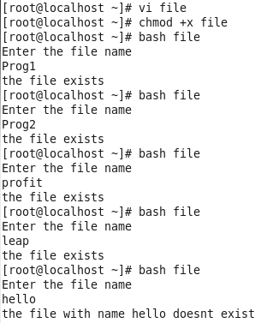

### Write a program to calculate the grade of a student on user input.

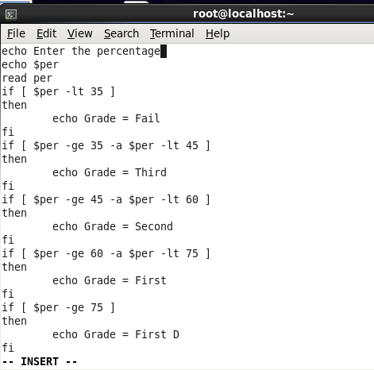

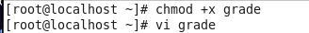

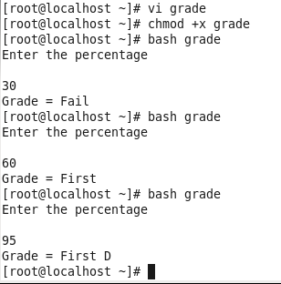

### Write a program to determine whether the number is negative or positive using elif.

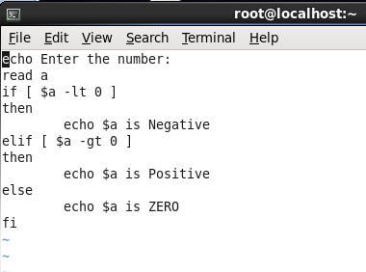

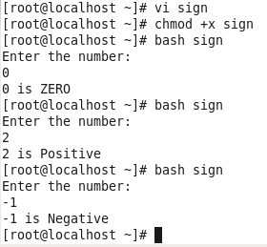

### Write a program to print the day of the week using case..in

**Create file:**

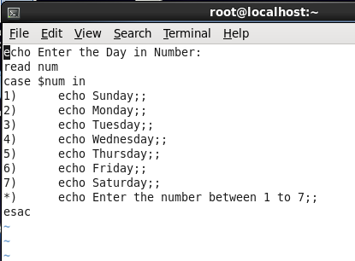

**Run chmod:**

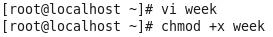

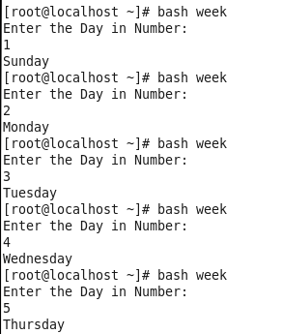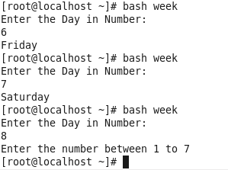

### Write a program to find the pattern in the word using case.

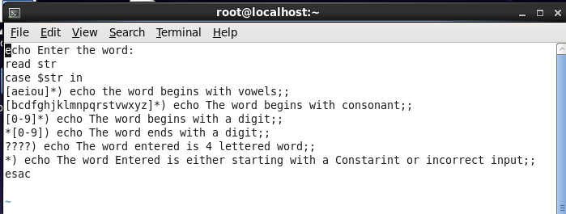

**CONSONANT:**

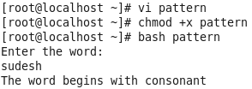

**VOWEL:**

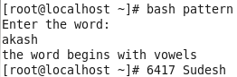

**NUMBER AT START:**

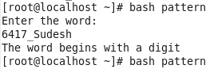

**CONSTRAINT:**

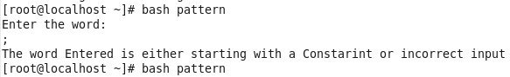

**4 LETTERED WORD:**

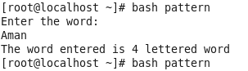

**ENDS WITH NUMBER:**

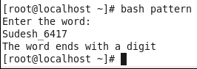

### Write a program to find the pattern in the word using case.

**SCRIPT:**

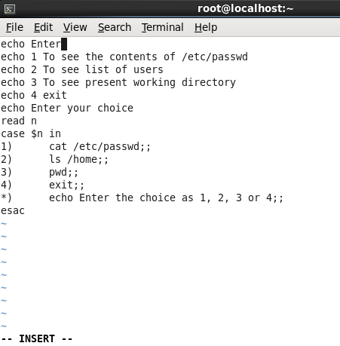

1. **To see contents of /etc/passwd**

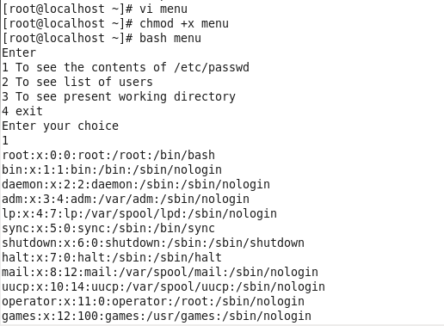

1. **To see list of users:**

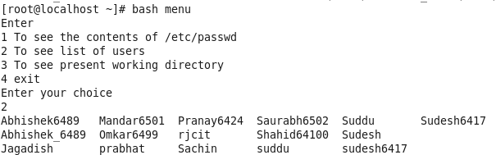

1. **To see current working directory**

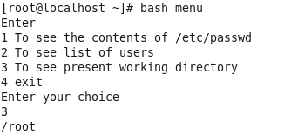

1. **To exit**

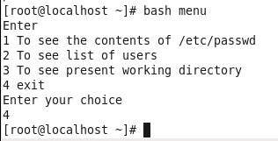

### Write a program to print first n numbers and their sum using a while loop.

**SCRIPT:**

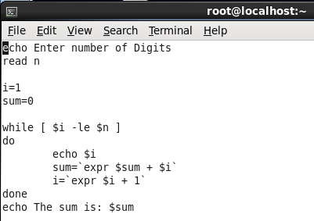

**RUN:**

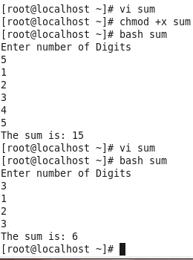

### Write a program to illustrate use of for loop.

**Script:**

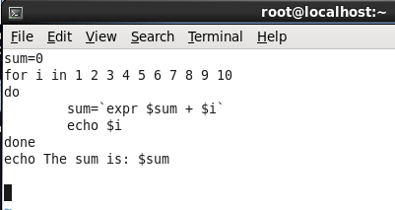

**RUN:**

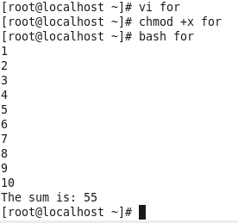

### Write a program to print table of a number using for loop.

**Script:**

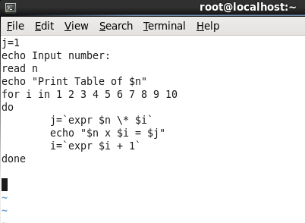

**Output:**

